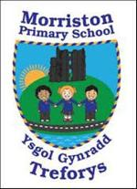
Year 4/5 – Spring term topic – ‘Wriggle and Crawl’
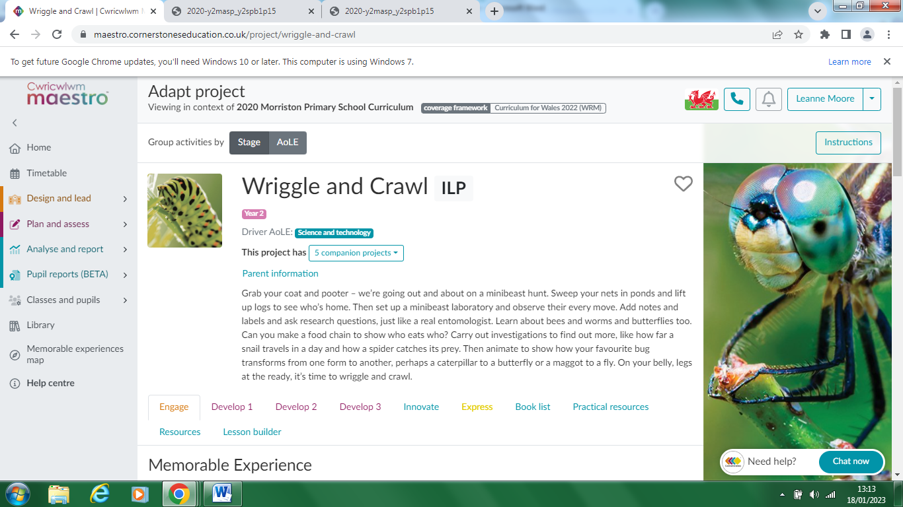

Please take some time to discuss/work with your child to discuss possible learning / questions they would like to find out during the Wriggle and Crawl topic. These ideas will aid future planning during the Spring Term.

Possible learning / questions to explore

Thanking you in anticipation,
Mrs Moore & Year 1/2 staff

