  Wk 08.03.21 |  |  | Theme: Burps, Bottoms and Bile  Spring Term 2021  Year group: 3-4 2020-2021
    Literacy  Remember to do your daily do’s as well: spelling, reading and handwriting practice…  Play:  Spell Blast – login to HWB- J2E- spell blast |   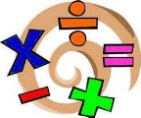  Numeracy  Remember to do your daily dos as well: timetables practice, adding 10 more, 10 less to a given number…  Play:  TTBlast – login to HWB- J2E- TTblast |     Creative |  |     Thinking  Email me your work, dojo points will be added, and merit prizes given when we eventually get back to face to face learning  Whitep7@hwbcymru.net | 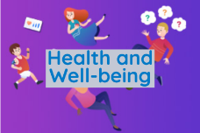    Healthy me  Daily check-in and catch-up chats send me a message by email (outlook) to let me know how you are whitep7@hwbcymru.net  Let me know if you are finding anything tricky or you need extra help.
Explanation writing:  Research and compare the digestive system of a human with that of a snake. Notice key similarities and differences. Report your discoveries, giving reasons for the differences, particularly those relating to diet.  Write to explain how a snake’s digestive system works. Use the explanation success criteria to help ensure that you include all the vital information. Remember best handwriting!  Class story ‘Demon Dentist’ by David Walliams  Chapter 8: listen to this week’s chapter: https://youtu.be/b_vj6VxeIyc  Reply using FlipGrid or send an email message to explain which character you identify with the most. Explain why you think you are like that character.  whitep7@hwbcymru.net  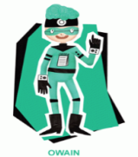  Healthy, confident individuals  Ambitious, capable learners  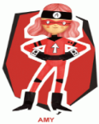  Spelling words for the first half of Spring term week 9, week 08.03.21  KEEP PRACTISING! | Grwp porffor, glas, oren a gwyrydd: Log into MyMaths  This week’s focus is TIME  https://www.bbc.co.uk/bitesize/topics/zkfycdm  Task 1: www.mymaths.co.uk  Task 2: challenge cards (see below)  Send an email to show me how you got on whitep7@hwbcymru.net  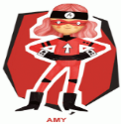  Ambitious, capable learners | Drawing bodies in pen:  Read through the PowerPoint drawing bodies with pen. Create a detailed drawing of a famous person and share with me. Don’t tell me who you have drawn! During our live check-in OR SCHOOL on wk15.03.21 I will share the drawings with you and we will try to guess who has been drawn.  Take a picture of your work and send to me whitep7@hwbcymru.net  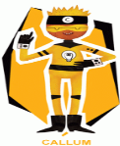  Enterprising, creative contributors  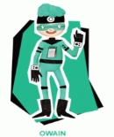  ^{Healthy, confident individuals} |  | Science week!  Below are 2 experiments for you to try at home:  1: straw water shooter  2: bottle orchestra  Dentistry through the ages:  ‘Awful Egyptians’  I want you to create a fact file (0ne A4 page on paper or in ADOBE Spark or Microsoft PowerPoint)  This link will help you learn about the  Awful Egyptians  https://www.bbc.co.uk/bitesize/topics/zg87xnb  Horrible Histories episode 4  https://youtu.be/U2bSim7TBHQ  Remember to include information about dentistry during this period.  ^{Healthy, confident individuals}  - He  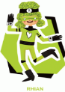  ^{Ethical, informed citizens}  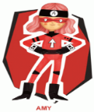  Ambitious, capable learners | It is looking likely that next week 15.03.21 you will be able to return to school. This may make you feel all sorts of things: happiness, scared, worried, excited, sad …  However, you are feeling I would love for you to talk about these feelings with your grown-up and share your worries/feelings with me.  Listen to the story The Colour Monster, and then complete your worry plan.  ‘A problem shared is a problem halved!’  The colour monster by Anna Llenas:  https://youtu.be/Ih0iu80u04Y  Share: whitep7@hwbcymru.net  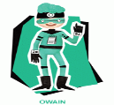  ^{Healthy, confident individuals}  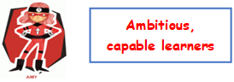
WWW – What went well?
EBI – Even better if …
My friend thinks –
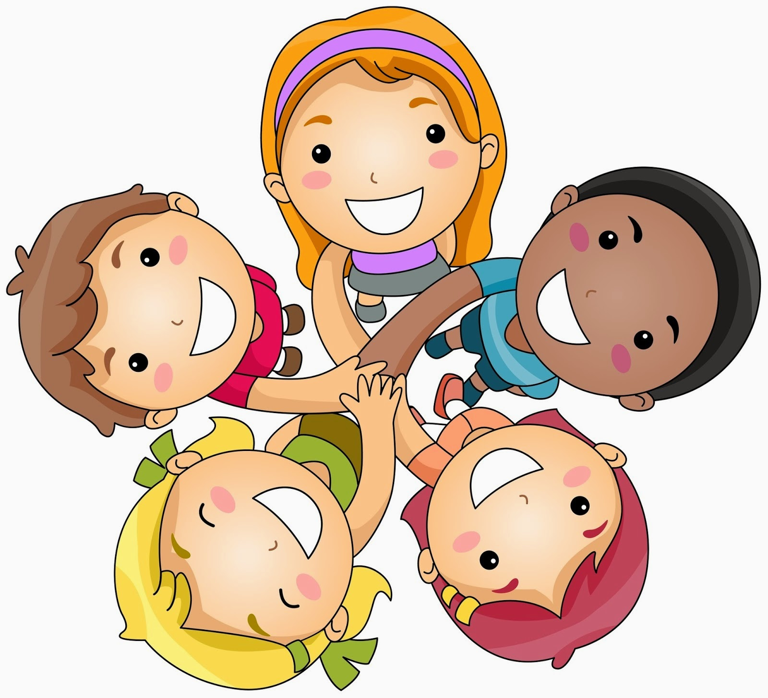

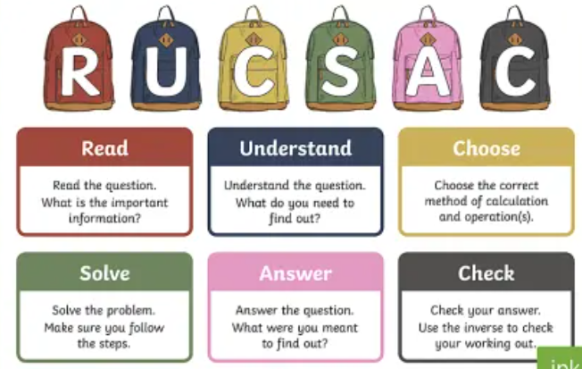
Problem solving task: ‘challenge cards!’

Remember to use a systematic approach (order)
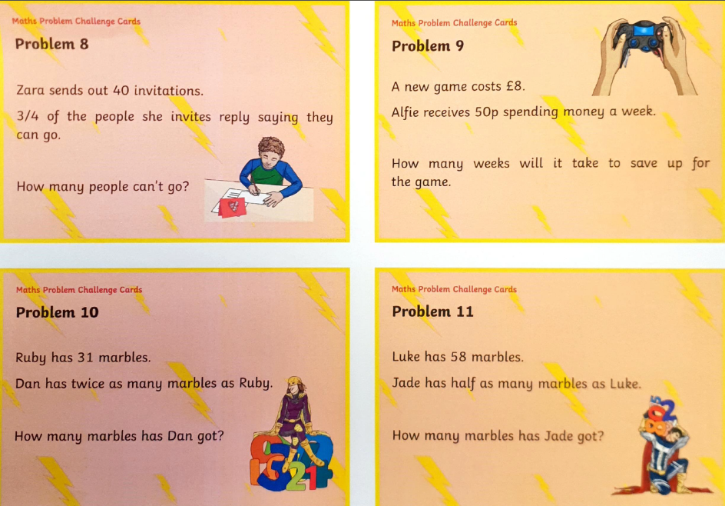

Straw water shooter
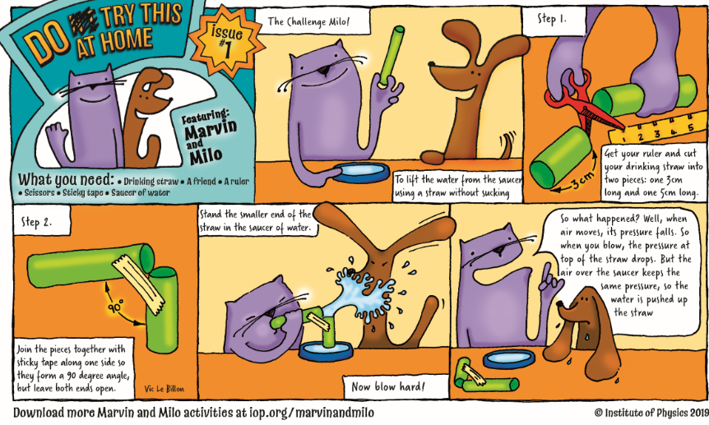

Bottle orchestra
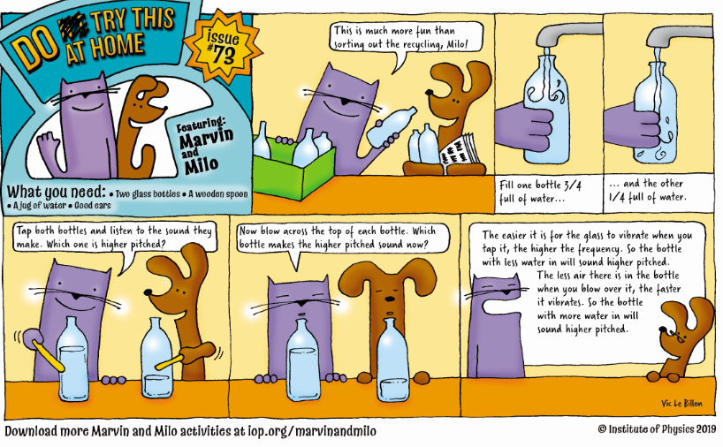

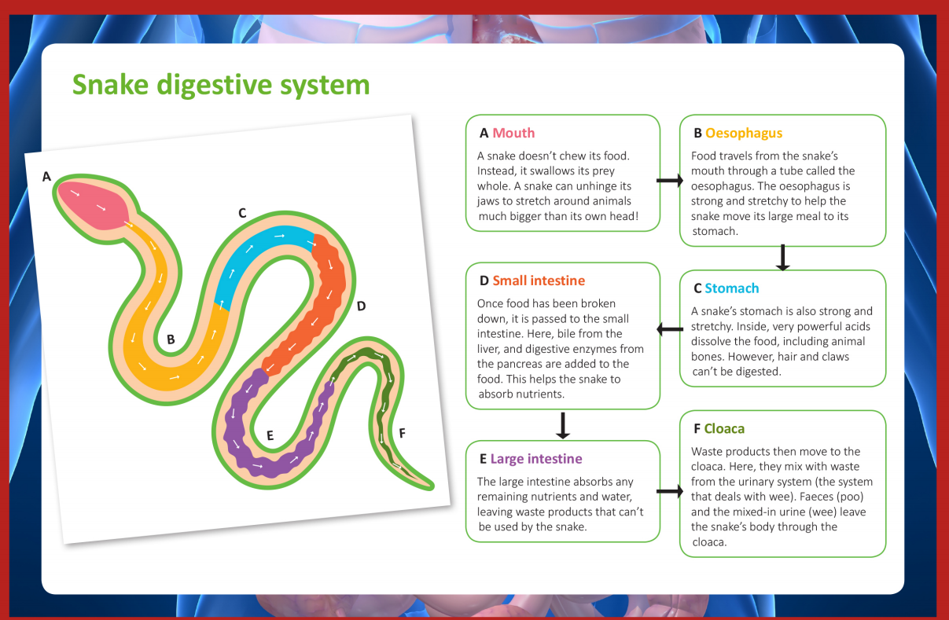

Writing to Explain
Key Stage 2
Text type features; | Self | Peer | Teacher
1. The title explains what the text will be about.
2. Present tense.
3. Third person (he, she, they).
4. Sequential order.
5. General opening statement.
6. Series of logical steps.
7. Time connectives – Next, . . Then, . . After a while, . . . Soon afterwards, . . . Finally, . .
8. Causal connectives - because, so, this causes, this results in, therefore… etc.
9. Pictures or diagrams to help with the explanation.
10. Technical vocabulary.
11. Commas after time connectives.
12. Vary sentence opening, sentence length and type.
13. Cause and effect.
14. Use adjectives to describe.

We all have worries, but it’s good to talk and share these

What is the worry? …………………………………………………………………………………………………………………
How big is the worry? (1 is tiny, 5 is huge)
1 | 2 | 3 | 4 | 5

Who is available to support me with the worry?
……………………………………………………………………………………………………………………………………………………….
Strategies to make the worry smaller:
Make a list of strategies that might help to make the worry smaller:

1. ………………………………………………………………………………………………………………………………………………..
2. ……………………………………………………………………………………………………………………………………………….
3. ……………………………………………………………………………………………………………………………………………..
4. ……………………………………………………………………………………………………………………………………………….
5. ……………………………………………………………………………………………………………………………………………….

