  1 |  |  |  | Theme: Burps, Bottoms and Bile  Year group: 3/4 PPA Mrs Watts
Literacy     | Numeracy  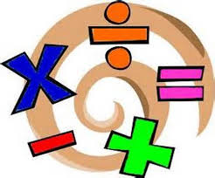   | Creative     | Thinking     |  | Healthy me    
Punctuation: Apostrophe for omission  Watch: Apostrophe for omission - YouTube about apostrophes for omission.  Complete as many of the activities as you can on the resource, ‘Skills for School’.  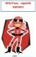  There is a bingo game you can also play on omissive apostrophes. | Reasoning:  Click on the link below to play the game, Nim-7 for Two: Nim-7 for Two (maths.org)  There are some questions below the activity, for you to answer, after you have played the game. Use the response sheet in Teams to answer the questions. |  | R.E: Christian Worship  Part One:  On the pupil response powerpoint in Assignments, answer these questions:  1). What is worship?  2). How do Chrisitans worship God?  Part Two:  Watch the clip:  Religious Studies KS2: Christian Worship - BBC Teach  After watching, answer this question on the powerpoint:  1). Which music did you like the best and why?  Part Three:  Listen to these examples of musical worship from different traditions:  Freedom by Jesus Culture - YouTube  God Forgave | Cross Culture Thailand VBS Music Video | Group Publishing - YouTube  Proclaim - Awesome God - YouTube  1). Why is this music used by some people to worship God?  2). What does the music mean?  3). What moods and emotions seem to go with the music?  4). If you had to choose music that was spiritual for you, what would you choose, for emotions, such as:  Joy  Thinking deeply  Sad times  Being together  Write your response on the powerpoint in Assignments.  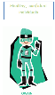 |  | P.E: Gymnastics  Complete a warm-up from the warm-up cards.  Follow the powerpoint, ‘Rolls’  Practice rolling and performing different types of rolls, safely.  Use Flipgride: https://flipgrid.com/dbdd114b  to record your movements.  Remember to cool down.

