  Wk 01.03.21 |  |  | Theme: Burps, Bottoms and Bile  Spring Term 2021  Year group: 3-4 2020-2021
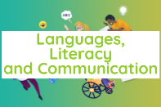    Literacy  Remember to do your daily do’s as well: spelling, reading and handwriting practice…  Play:  Spell Blast – login to HWB- J2E- spell blast |     Numeracy  Remember to do your daily dos as well: timetables practice, adding 10 more, 10 less to a given number…  Play:  TTBlast – login to HWB- J2E- TTblast | 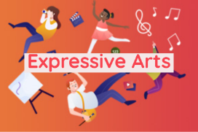    Creative  *Please send me a picture of yourself in your Welsh cosutmes or rugby tops. I would like to create a collage of all your photos |  |     Thinking  Email me your work, dojo points will be added, and merit prizes given when we eventually get back to face to face learning  Whitep7@hwbcymru.net | 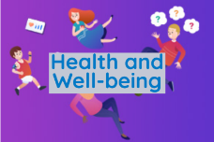    Healthy me  Daily check-in and catch-up chats send me a message by email (outlook) to let me know how you are whitep7@hwbcymru.net  Let me know if you are finding anything tricky or you need extra help.
Happy St David’s Day  ‘Dydd Gwyl Dewi Sant Hapus’  Your task this week is to create a St David’s Day word search. You can use a mixture of English words related to Wales and any Welsh vocabulary words you can think of. The template is below, send me your word searches so I can find the words you’ve hidden  Class story ‘Demon Dentist’ by David Walliams  Chapter 7: listen to this week’s chapter:  https://flipgrid.com/e05dc1a4  Design an advert to promote Miss Root's 'Mummy's toothpaste'.  Cast you minds back to when we made adverts to promote and sell our Gonk mugs at Christmas time.  We need to persuade people that this toothpaste is effective, you will have to put yourself in the shoes of Miss Root! (argh!)  Adverts:  Success Criteria: Literacy persuasive advert-  Have a snappy slogan to make the toothpaste sound amazing  Include information about what the toothpaste can do  Use bold writing, images and colour to make our advert stand out  You can complete the advert as a poster on paper or using Adobe Spark poster or even use Adobe Spark to make video advert, you decide.  whitep7@hwbcymru.net  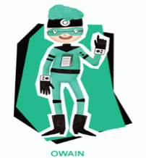  Healthy, confident individuals  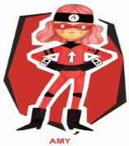  Ambitious, capable learners  Spelling words for the first half of Spring term week 8, week 01.03.21  KEEP PRACTISING! | Grwp porffor, glas, oren a gwyrydd: Log into MyMaths  Task 1: www.mymaths.co.uk  -angle and position  -fractions of an amount  Task 2: St David’s Day numeracy task (see below)  Task3: Problem solving task, ‘Seven Up!’ see below.  Send an email to show me how you got on whitep7@hwbcymru.net  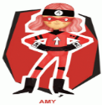  Ambitious, capable learners | As part our St David’s Day celebrations your mission this week is to create either a) the prettiest daffodil or b) the biggest leak.  Whichever Welsh emblem you decide to choose. You will need to find out why it is special to Wales and write to tell me all about it.  To create your emblem you can use any medium you want: collage, painting, drawing etc.  World Book Day Competition  ‘Create a potato friend!’ Challenging pupils to turn a boring old potato (or egg) into a book character.  Be creative and use what you have available by Thursday 4 March.  Take a picture of your work and send to me whitep7@hwbcymru.net  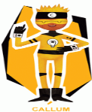  Enterprising, creative contributors  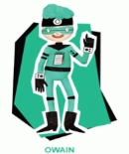  ^{Healthy, confident individuals} |  | Mission 1  Fairtrade Fortnight 2021 22.01.21-07.03.21  Your mission is to reflect on the journey of a chocolate bar and consider all of the people and places who were involved in its production. Do our choices as a consumer affect this journey?  Mission 2  Dentistry through the ages:  ‘Gorgeous Georgian’  I want you to create a fact file (0ne A4 page on paper or in ADOBE Spark or Microsoft PowerPoint)  This link will help you learn about the Gorgeous Georgian  www.bbc.co.uk/bitesize/topics/z3kqmp3/resources/1  Horrible Histories episode 3 Gorgeous Georgian  https://youtu.be/azOy1EixtuM  Remember to include information about dentistry during this period.  ^{Healthy, confident individuals}  - He  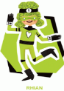  ^{Ethical, informed citizens}  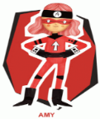  Ambitious, capable learners | Tracking my feelings:  Look at the emotions/feelings prompts and discuss with your grown-up what each emotion means.  Your mission is to track your emotions at different points through the day for a week. Write down the activity you were doing, The feeling you were experiencing. If possible, also note down the reason you were feeling like that.  Share: whitep7@hwbcymru.net  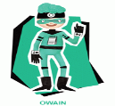  ^{Healthy, confident individuals}  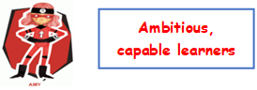
WWW – What went well?
EBI – Even better if …
My friend thinks –


Problem solving task: ‘Seven up!’

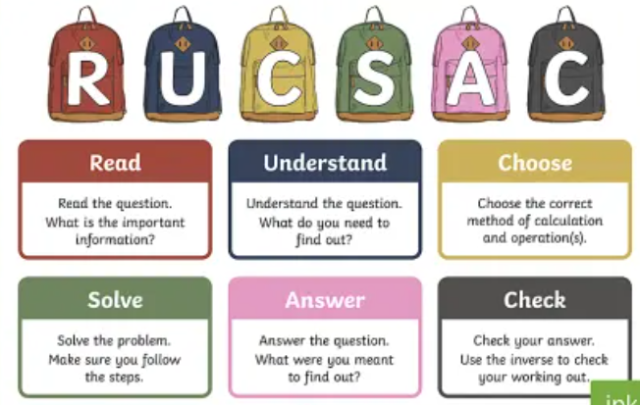
Remember to use a systematic approach (order)
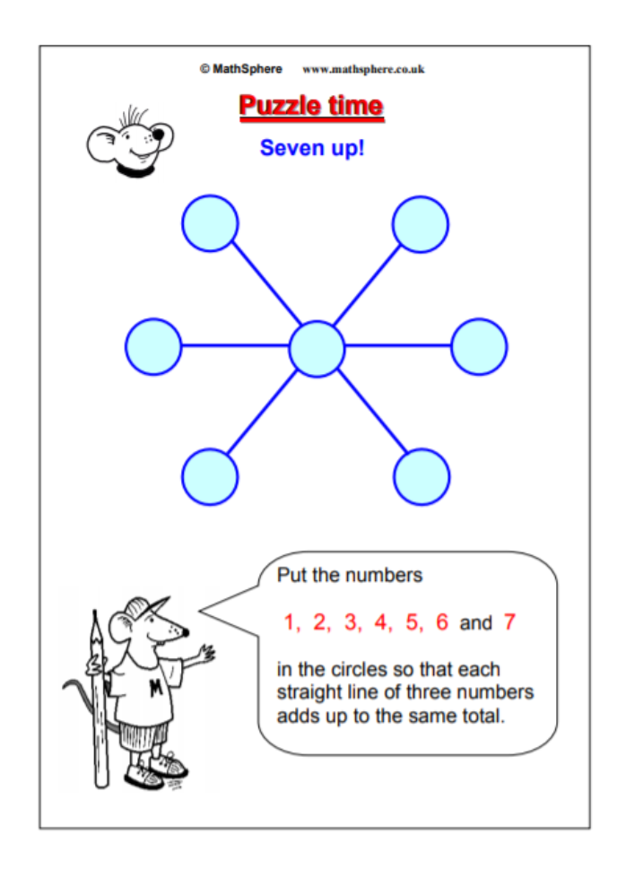


St David’s Day Word Search

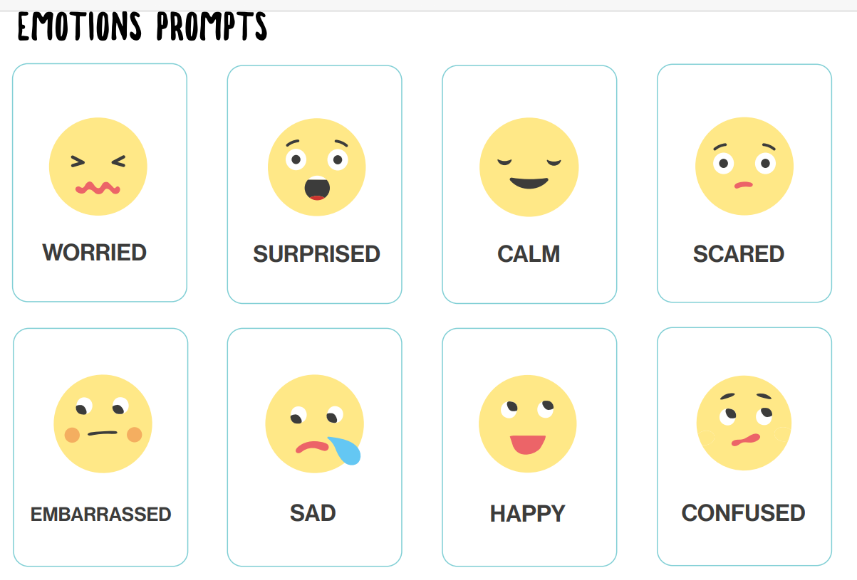

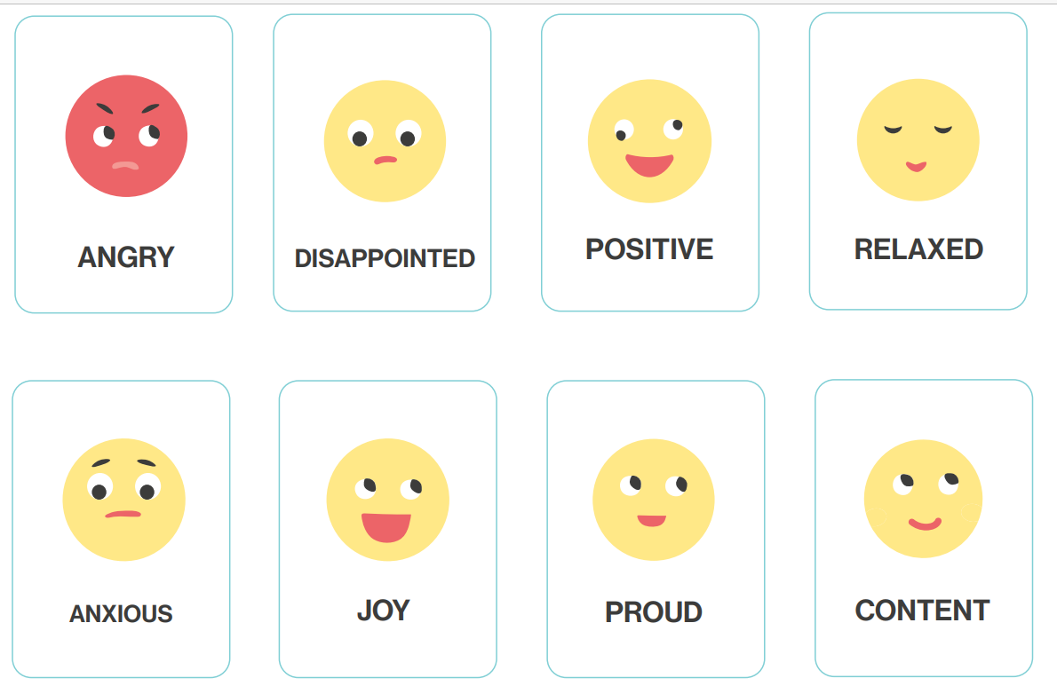

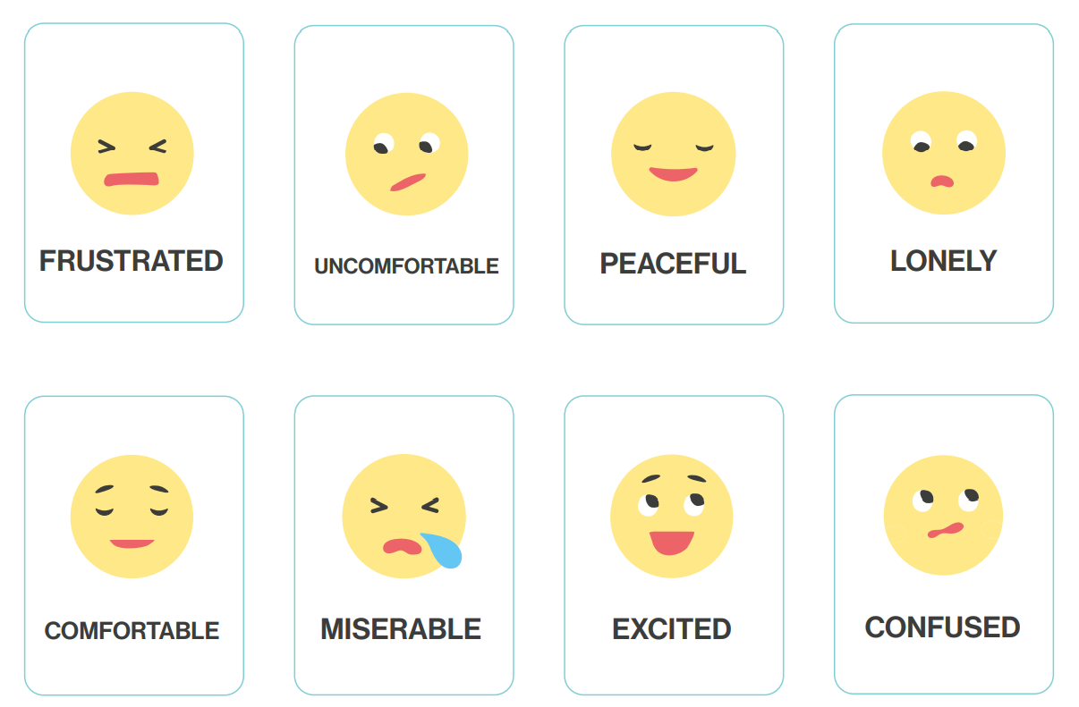

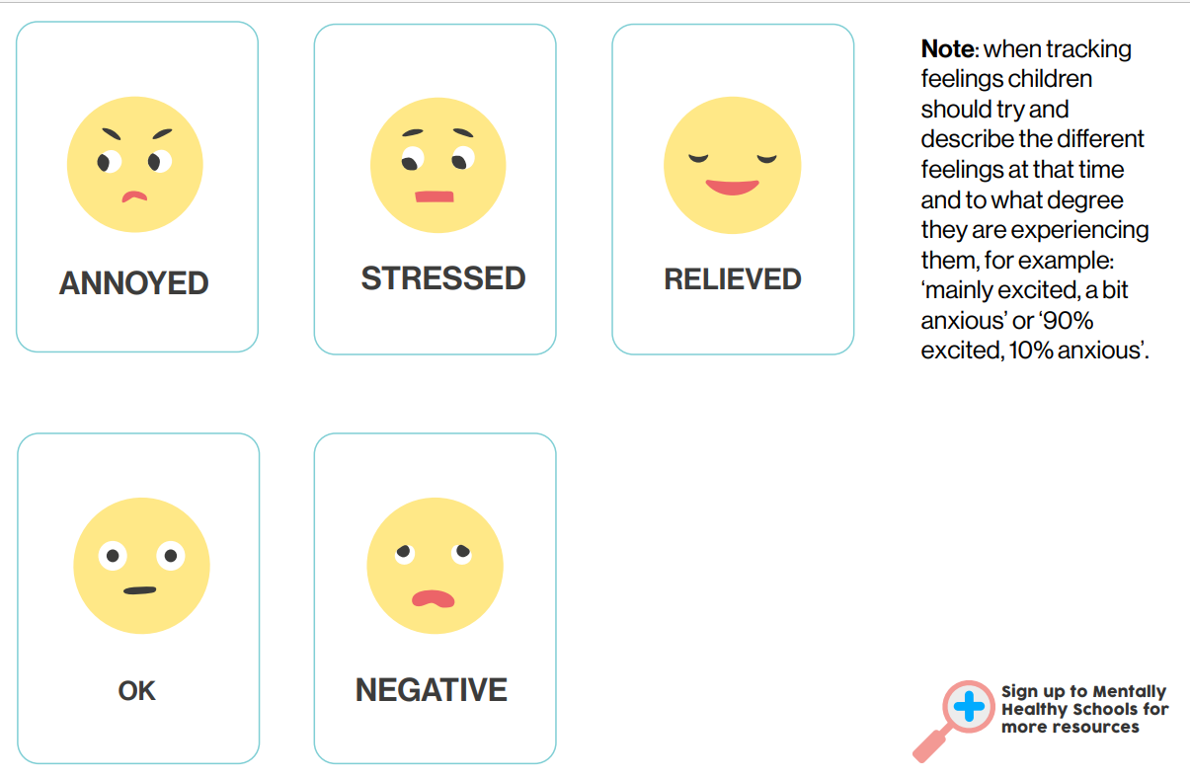
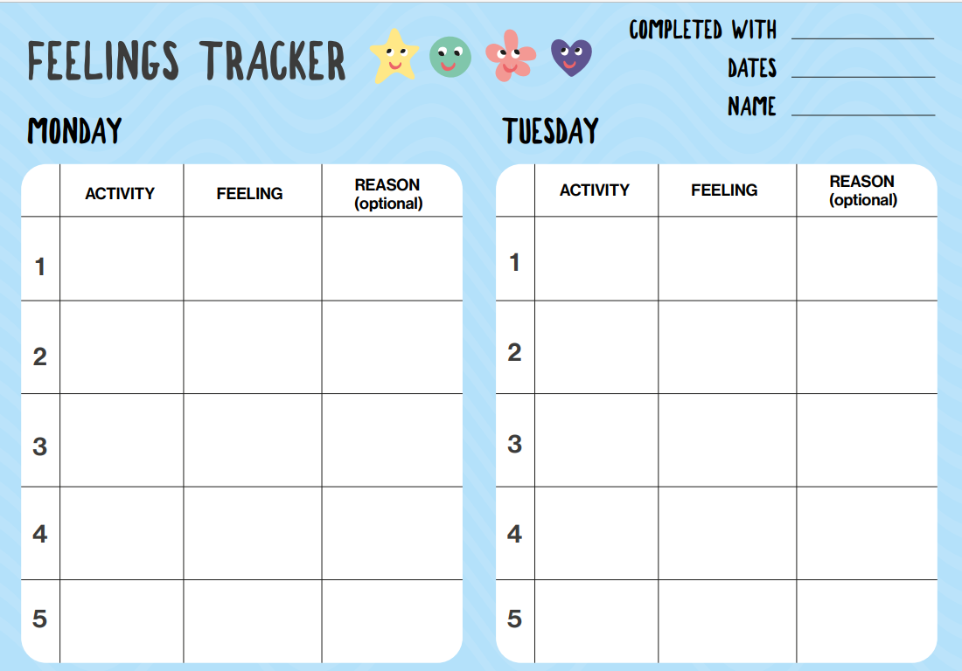

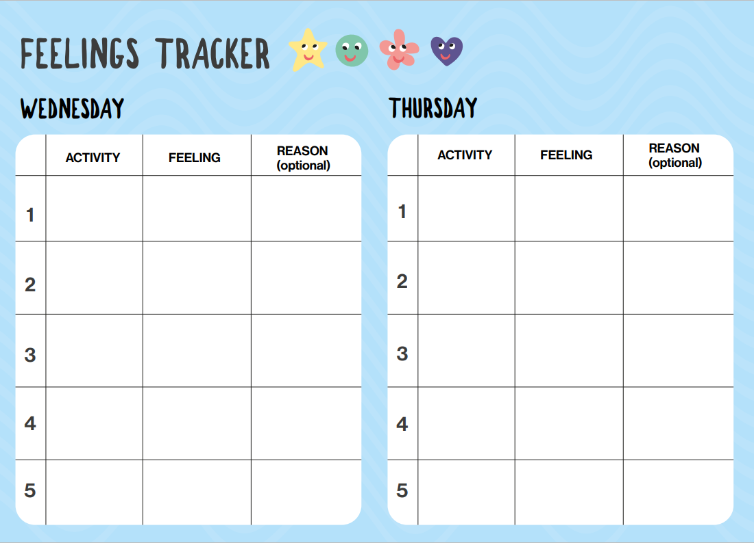

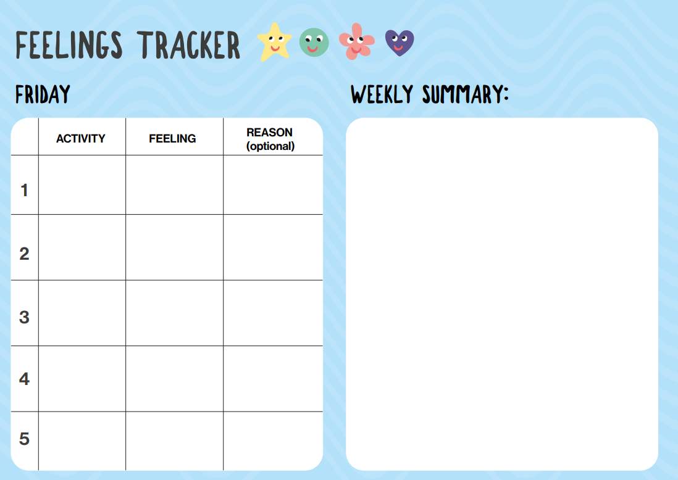

World book day live sessions
- During our Wednesday 3rd March 2021 live session, I want you to share your favourite story book, name the author and tell me why you like the book.
Thursday 4th March 2021
- World Book Day Live lesson 11.30am BBC Teach https://www.bbc.co.uk/programmes/m000stdg
Other ideas activities and weblinks:
Daily Newsround: Watch CBBC Newsround and make a report, this can be sent as a video clip if you want to be recorded or can be sent as a written report.
https://www.bbc.co.uk/newsround
An excellent resource which has online lessons specific to the year group with lots of games and ideas.
https://www.bbc.co.uk/bitesize
Reading: Read a book a little at a time, if you would like to send in a recording of you reading then we would love to hear, reading is so important. Remember you can use the Oxford Owl online books log on to https://www.oxfordowl.co.uk/ and use the login/password ‘white18’.
Creative writing with Pobble365, an excellent resource with daily story ideas. Write an introduction, paragraph, story ending or present your work as a picture, comic or story board, be as creative as you like.
https://www.pobble365.com/
National Geographic is a fantastic site with lots of colourful images, videos and information that explores the world around us, an excellent resource.
https://kids.nationalgeographic.com/animals/
Tate Gallery London (Tate Kids) website, has lots of lovely arts and craft activities and online games and resources.
https://www.tate.org.uk/kids
Contact: whitep7@hwbcymru.net

