Year 4/5 – Spring term topic – ‘Stargazers ’
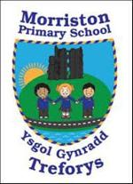
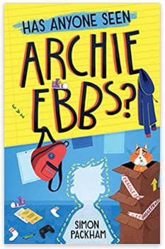


Journey through space! Let’s take a trip to the stars, planets and suns and discover the amazing wonders of the night sky.

Our topic this term is ‘Stargazers’. The topic has a scientific focus, and teaches children about the Solar System. Learners will study the Moon, planets and significant individuals such as Galileo and Newton.

Children will investigate lunar myths and create an information text based on the planets. Learners will design and make a space shuttle or satellite, testing the materials for durability, and program/ code a rover to explore a lunar landscape.

This term our class novel is ‘Has Anyone Seen Archie Ebbs?' by Simon Packham. We will be using this novel to develop our empathic skills via the EmpathyLab model.

More information on EmpathyLab can be found at: www.empathylab.uk

Please take some time to discuss/work with your child to discuss possible learning / questions they would like to find out during the Stargazers topic. These ideas will aid future planning during the Spring Term.
Possible learning / questions to explore

Thanking you in anticipation,
Mr Bannister & Year 4/5 staff

