  1 |  |  |  | Theme: Burps, Bottoms and Bile  Year group: 3/4 PPA Mrs Watts
Literacy     | Numeracy  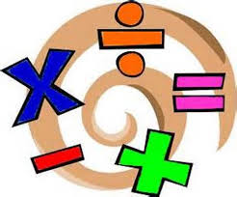   | Creative     | Thinking     |  | Healthy me    
Grammar: Homophones  Click on the link:  Homophones - Year 3 - P4 - English - Catch Up Lessons - Home Learning with BBC Bitesize - BBC Bitesize  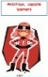  Complete the activities. Use the homophone response sheet to record your story. Also, play the Superheroes Game. Click on Steve to play the homophone game. | Reasoning: Ordering Cards  Click on the link below to complete the task:  Ordering Cards (maths.org)  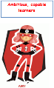  There is more information for parents, about this task, under the link, ‘Teacher Resources’ on the left of the page. |  | R.E: Why is prayer and worship important to Christians?  Read the powerpoint, ’Christian prayer and worship’. Discuss the questions with a family member.  Complete the activity on the last slide – to write your own prayer. |  | 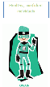  P.E: PE lesson for year 3/4.  Click on the link to create a sequence of movements:  Week 18, PE lesson for year 3 & 4 - YouTube  Use the flipgrid code below, to send me a video of your dance sequence and explain what you did: https://flipgrid.com/b296ebcf

