  Wk 01.02.21 |  |  | Theme: Burps, Bottoms and Bile  Spring Term 2021  Year group: 3-4 2020-2021
    Literacy  Remember to do your daily do’s as well: spelling, reading and handwriting practice…  Play:  Spell Blast – login to HWB- J2E- spell blast |     Numeracy  Remember to do your daily dos as well: timetables practice, adding 10 more, 10 less to a given number…  Play:  TTBlast – login to HWB- J2E- TTblast |     Creative |  |     Thinking  Email me your work, dojo points will be added, and merit prizes given when we eventually get back to face to face learning  Whitep7@hwbcymru.net |     Healthy me  Daily check-in and catch-up chats send me a message by email (outlook) to let me know how you are whitep7@hwbcymru.net  Let me know if you are finding anything tricky or you need extra help.
Class story ‘Demon Dentist’ by David Walliams  Chapter 4 direct speech/inverted commas:  Listen to this week’s chapter as many times as you would like.  https://flipgrid.com/122b4f92  Your mission is to write the next paragraph, remember to use adjectives to describe what is going on, including the thoughts and feelings of the characters. Use direct speech in your written work, to show when a character is talking.  Click the link below or copy and paste into your search browser for extra help using direct speech in your writing.  www.bbc.co.uk/bitesize/articles/z8d78hv  Take a picture of your work and send to me via Dojo or whitep7@hwbcymru.net  https://flipgrid.com/52acd3a3  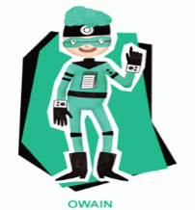  Healthy, confident individuals  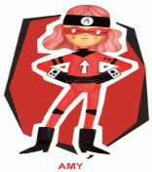  Ambitious, capable learners  Spelling words for the first half of Spring term week 5, week 01.02.21  KEEP PRACTISING! | Grwp porffor, glas, oren a gwyrydd: Log into MyMaths  www.mymaths.co.uk  Task 1: Measuring lengths- REMEMBER to watch the lesson first!  Watch this lesson below for extra measuring tasks  https://youtu.be/azeQ--rFG5Y  Task2: Problem solving task, see below.  Send an email to show me how you got on whitep7@hwbcymru.net  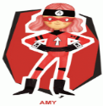  Ambitious, capable learners | Sir Charles Scott Sherrington: 1857-1952:  Following on from last weeks work on muscles this week your mission is to Imagine the inside of your head!  Draw a picture of you and your brain  What colours and textures can you use?  What feelings and thoughts?  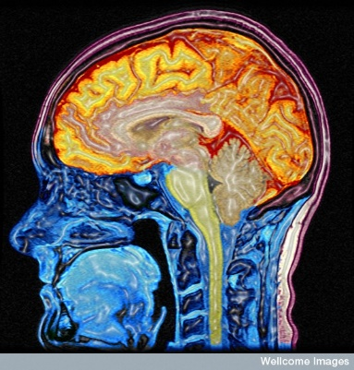  You can complete this mission anyway you want e.g. a 3D model, painting, digital artwork… you decide!  Take a picture of your work and send to me whitep7@hwbcymru.net  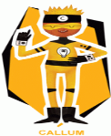  Enterprising, creative contributors  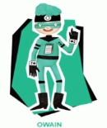  ^{Healthy, confident individuals} |  | The Digestive System  ADOBE Spark  Find out more about the digestive system. Click and drag the labels into the correct position. Use Adobe Spark portfolio to add images, text, and voice recordings to explain how the ‘digestive system’ works.  Click share- publish and send me the link to your Adobe Spark portfolio  Whitep7@hwbcymru.net  ^{Healthy, confident individuals}  - He  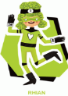  ^{Ethical, informed citizens}  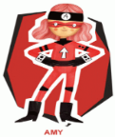  Ambitious, capable learners | Children’s Mental Health week  - Watch your favourite feel good movie.  - Review your movie telling me all about it.  - Express yourself anyway you want e.g. draw a picture, sing your favourite song, do whatever you enjoy the most but most importantly have fun!  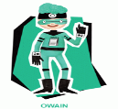  ^{Healthy, confident individuals}  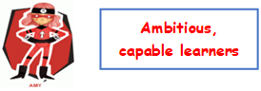
WWW – What went well?
EBI – Even better if …
My friend thinks –


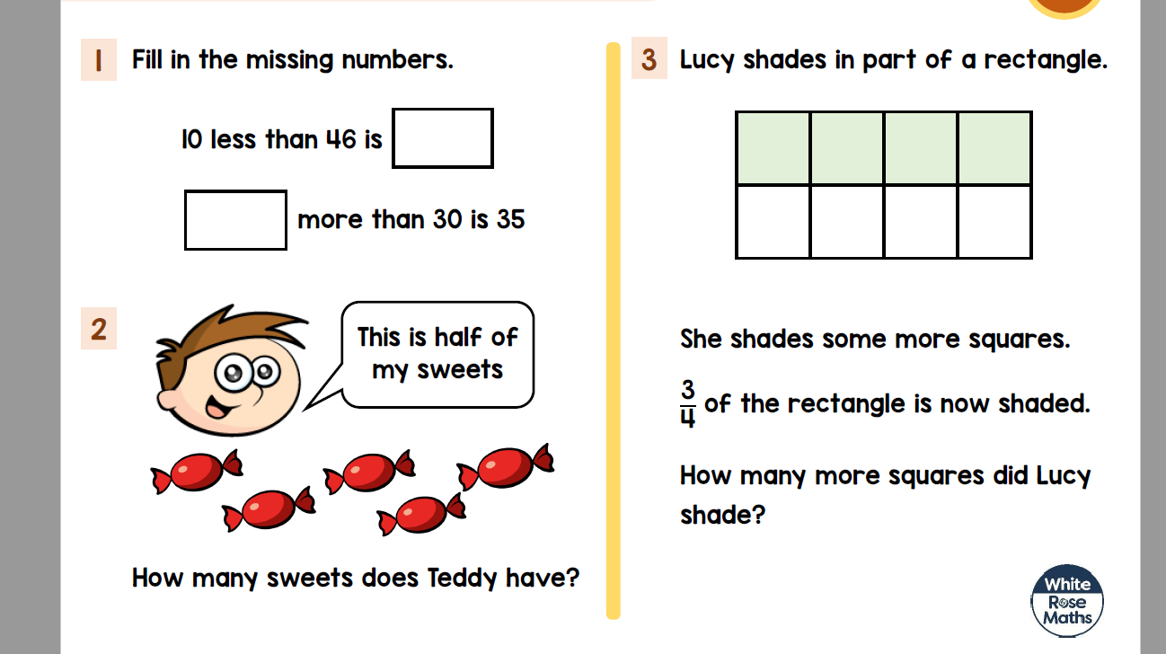

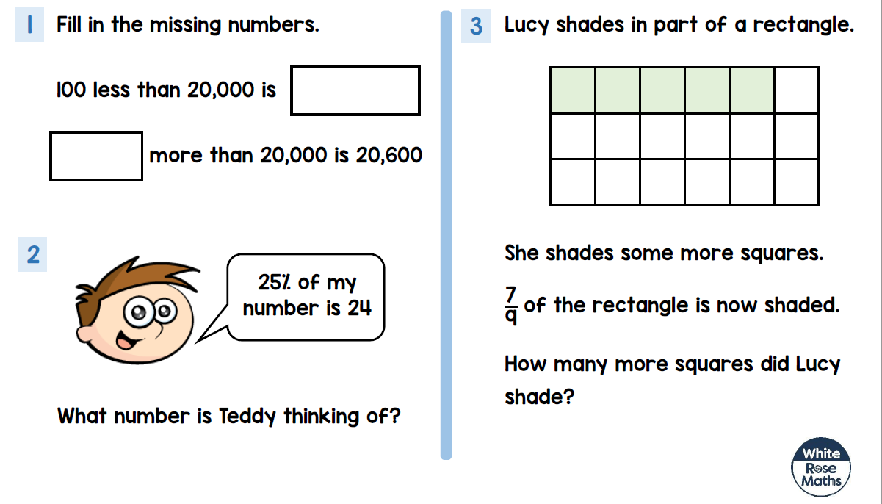

Digestive System: On a device click and drag the labels into their correct positions. Printed copy cut and stick the labels into the correct position. On paper draw the outline and write on the labels to explain the process of the digestive system



