  1 |  |  |  | Theme: Burps, Bottoms and Bile  Year group: 3/4 PPA Mrs Watts
Literacy     | Numeracy  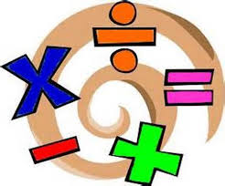   | Creative     | Thinking     |  | Healthy me    
Grammar: Comparatives and Superlatives  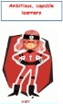  Read the resource and complete the task. Do as much as you can. | Reasoning: Magic V  Click on the link below to complete the task:  Magic Vs Poster (maths.org)  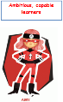  There is more information for parents, about this task, under the link, ‘Teacher Resources’ on the left of the page. |  |  |  | PSE: ‘Proud’  Complete the resource sheet. What is ‘proud’?  Write down your proudest moments this week.  P.E: Yoga for Children  Click on the link:  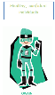  Kids yoga - Lesson 1 (3 - 8 year olds) - YouTube

