Name: Date:

Adjectives, Comparatives and Superlatives
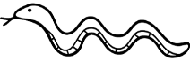
ADJECTIVES
This snake is long

Adjectives are words that describe nouns.

COMPARATIVE ADJECTIVES
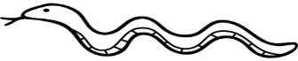
Comparative adjectives are used to compare differences between two objects.
They are used in sentences where two nouns are compared
This snake is longer than the 1st snake.

SUPERLATIVE ADJECTIVES

Superlative adjectives are used to describe an object which is the best, biggest, smallest etc.
They are used in sentences where a noun is compared to a group of many objects.
This snake is the longest
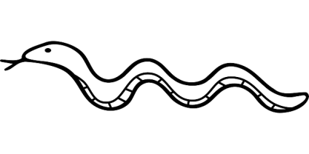

RULE: For 1 syllable adjectives you add ‘er’ to the adjective to make a comparative, and ‘est’ to the adjective to make the superlative.
Practice:
- My hair is long, Jill’s hair is longer than mine, but Ann’s hair is the longest.
- A dog can run fast, a rabbit can run ________________, but a
cheetah can run the _________________ .
- I am tall, my sister is __________________ than me, but my Dad is the ___________________ .
- It is quite hot inside our classroom, it is much ______________ outside, but it is the _________________ on the equator.
- My big brother is strong, my dad is ____________, but my Uncle (who is a policeman) is the _____________.
- My aunt is quite old, my uncle is _________________ than her, but my grandad is the ___________________.
- An apple is sweet, a mango is ________________, but sugar is the __________________ of all.
- A book is cheap, a pencil is _______________, but an eraser is the ______________ thing in the shop.

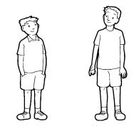
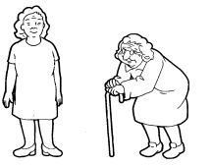
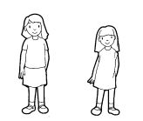
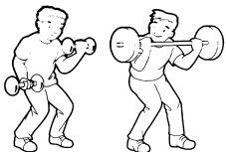
- My snack box is large, my friend’s snack box is __________, but my teacher’s snack box is the ___________.

- I am clever, my brother is __________________, but my mum is the _____________________.
RULE
If the adjective has more than 2 syllables then we use the Comparative “more” before the adjective and “than” after the adjective
e.g beautiful - more beautiful than
If the adjective has more than 2 syllables then we use the Superlative “most” before the adjective.

Example: adjective: comfortable
My old blue t-shirt is more comfortable than my new t-shirt, but my football shirt is the most comfortable.

Let’s practice:

1) Jane is ________________________ Christina, but Sally is the ________________________ (beautiful)

2) This cookie is ________________________the chocolate one, but the peanut cookie is the ________________________ (delicious)

3) John is ________________________Peter, but Luke is the ________________________ (intelligent)

4) Math is ________________________English, but Chinese is the ___________________ (difficult)

5) Sam is ________________________David, but Adam is the ________________________ (interesting)

6) Science is ________________________English, but watching TV is ________________________ (boring)

7) A car is ________________________a bike, however a helicopter is the ________________________ (expensive)

8) My house is ________________________yours, but the Tim’s flat is the ________________________ (modern)

9) My drawing is ________________________Adam’s, but Nisa’s is the ________________________ (colourful)

10) The book is ________________________the film, but the website is the ________________________ (interesting)

11) Tom is ________________________than Peter, but Ben is the ________________________ (helpful)

