  1 |  |  |  | Theme: Burps, Bottoms and Bile  Year group: 3/4 PPA Mrs Watts
Literacy     | Numeracy  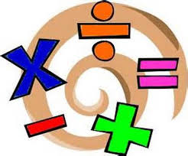   | Creative     | Thinking     |  | Healthy me    
Spelling: words with the suffixes -ment and -ness  Play the suffix matching cards games – there is one game for the suffix  -ness and one game for the suffix -ment.  Pick 5-8 words from each game and write them in sentences. If you want to write a story or paragraph with the words, then please feel free to do so.  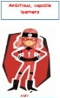 | Reasoning: Fifteen cards  Click on the link below to complete the task:  Fifteen Cards (maths.org)  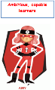  There is more information for parents, about this task, under the link, ‘Teacher Resources’ on the left of the page. |  | R.E: Christian Symbols in Church  Read the powerpoint, ‘Christian Symbols’ to learn what a symbol is and what Christian symbols mean.  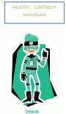  Complete the task, at the end of the powerpoint. |  | P.E: Speed Bounce Challenge  Click on the link:  Home PE | KS2 Speed Bounce Challenge - YouTube  Remember to count your bounces. Bend your knees as you land softly.  What do you notice about the changes in your body after exercise? Let me know your personal best (pb) score. Good luck!  

