Dannedd - Teeth
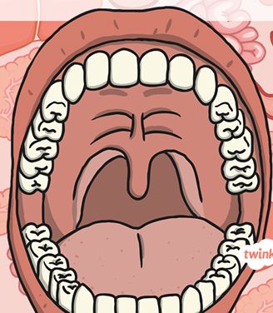

Look in the mirror and try to count how many teeth you can see:
Say that number in Welsh
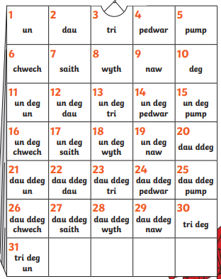

Answer this question in Welsh using your language patterns and your Welsh numbers:
Faint o ddannedd sydd gyda ti / How many teeth do you have?

____________________________________________________________________________________________________________________________________________________________________

Types of Teeth
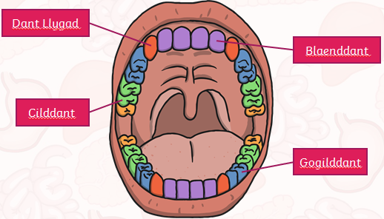
Blaenddant (front teeth) Lower Incisors
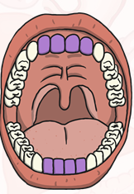
Dannedd Llygaid – Upper and Lower Canines
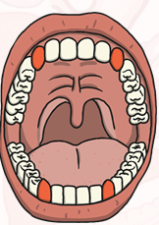

Gogilddannedd - Premolars
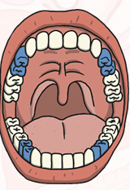
Cliddannedd – Molars
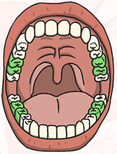

Mission 1:
If you have a printing facility; print out the mouth template then print and cut the different teeth and place them in the correct place.
Label them in Welsh.




