Lean on Me—Bill Withers
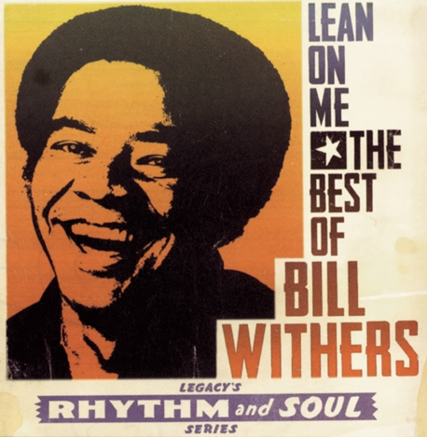

- Copy and paste the you tube link into your search engine.
- Listen to the song.
- Answer the questions below (you can use this page for your answers)

Questions:
- Do you like the song and why?

- What can you hear in the song?

- What is the style of the music? (soul, pop, rock, ballad, rap, r&b, gospel)

- How is the song put together? For example: verse; chorus, instrumental, introduction.

- Find some information about the composer.

- When he was born?
- Where he lived?
- What style of music did he compose?
- Were there any factors that inspired him to compose?
- Name some of the other songs that he composed.

