Burps, Bottoms and Bile – Torri Gywnt a Phethau Eraill – Lesson Overview
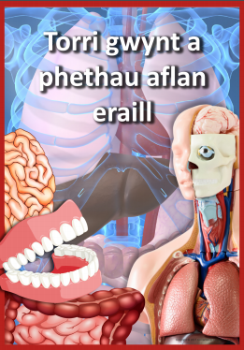

Welsh Language Mission:
Body Parts.
Last week we looked at the different foods and their names in Welsh, then you created a healthy plate and an unhealthy plate and created some sentences using your language patterns.
This week we will look at the different parts of the body and their names in Welsh.
Click on the QR code to listen to me singing the Head Shoulders Knees and Toes song in Welsh (you will probably remember singing it in school)

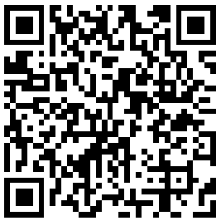
Look at the diagrams with the labelled body parts. See if you can recognise some of the parts in Welsh. There will be some that you’re not familiar with, so to help you, click on the second QR code to learn how to pronounce each body part.
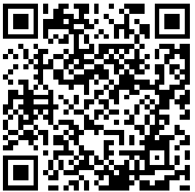
Task 1:
- Draw a picture of the outline of your body.
- You can do this on A4 paper or if you want to be a little more adventurous you can use large pieces of paper or an old roll of wall paper if you have it and have someone draw around your body (see picture). You can also use the template at the bottom of the page. If you want to use ICT you can create and label your body parts on the computer.
- Once you have done this – label all the body parts in Welsh.
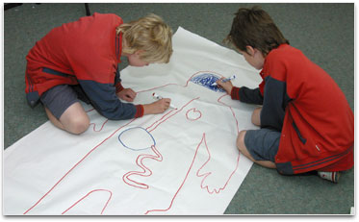

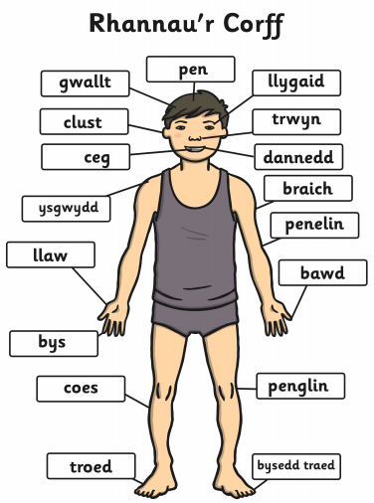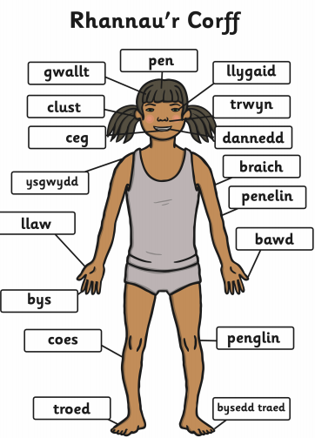
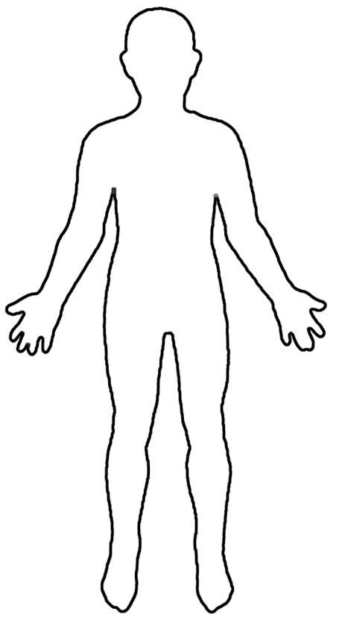

Welsh Language Mission 2:

