
Templed Gweithgaredd Cymraeg /Welsh Mission Template 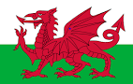

Welsh Language Mission #1:

Look at the attached food word mat with the Welsh names for each food type. Create a ‘Healthy Plate’ (Plât iachus) and an ‘Unhealthy Plate’ (Plât Afiach).
You can use the attached ‘plate’ template or draw your own.
Cut the foods out and glue them on each plate or draw your own foods – label each item in Welsh.
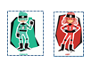
Welsh Language Mission #2:
Write up to 6 sentences about some of the foods that you like (dw i’n hoffi) and don’t like (dw i ddim yn hoffi).
You can up level your work by giving reasons for liking or disliking the choice of foods.



