The 4 Core Purposes:
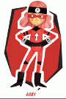
Amy – Ambitious and Capable Learners

 Owain – Healthy and Confident Individuals

LO: To learn the names of the different foods in Welsh.
To design a healthy and unhealthy plate:
draw the foods on the plates and name them.

Burps, Bottoms and Bile – Torri Gywnt a Phethau Eraill – Lesson Overview
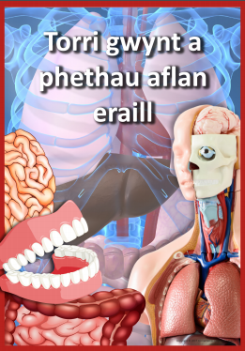

Welsh Language Mission 1:
Look at the attached food word mat with the Welsh names for each food type. Create a ‘Healthy Plate’ (Plât iachus) and an ‘Unhealthy Plate’ (Plât Afiach). Label each plate with the titles in Welsh.
You can use the attached ‘plate’ template or draw your own.
Cut the foods out and glue them on each plate or draw your own foods – label each item in Welsh.

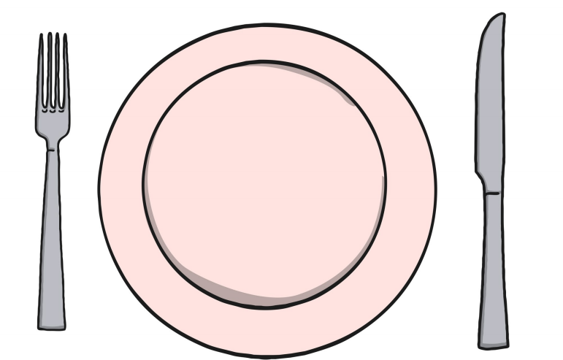

Welsh Language Mission 2:
Once you have completed your healthy and unhealthy plate look at your attached Welsh language patterns.
Write up to 6 sentences about some of the foods that you like (dw i’n hoffi) and don’t like (dw i ddim yn hoffi).
You can up level your work by giving reasons for liking or disliking the choice of foods. You do not have to give a reason in all of your sentences.
If you find that you don’t know the Welsh word for something you can use the Welsh dictionary app or website to help you:
https://www.bangor.ac.uk/canolfanbedwyr/ap_geiriaduron.php.en

Here is an example of a sentnce you can write:
Dw i ddim yn hoffi caws achos mae en ych a fi
Dw i’n hoffi pysgod a sglodion achos mae’n flasus iawn

