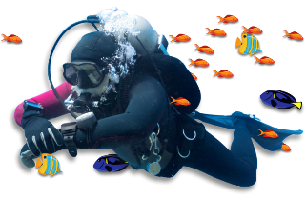
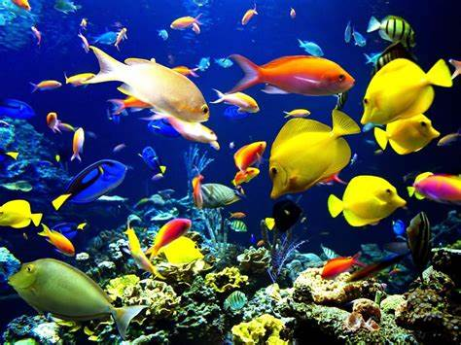
Blue Abyss Homework Matrix
Over the next term, Year 4 & 5 will be learning about the oceans around the world.
In the grid below, you will find many interesting activities for you to complete at home. Choose one activity each week to complete in your homework book. Your book will need to be returned to school every Wednesday for the class reflection time where homework will be displayed and shared with class peers.
Literacy, Languages and Communication  Use a dictionary to help you write definitions for the topic-related words listed.  Extension: Create sentences containing the words above. | Science and Technology  Use online sources or information books to find out about the world’s five oceans. Record your findings in a table. Include facts about each ocean’s size, temperature, characteristics and animal life. | Expressive Arts  Look at examples of artists who create artwork of marine life or endangered marine species, such as Amber Marine, Jenny Berry and Michael Hoffman. Choose an artist whose work you like and use their style as inspiration for creating a marine-inspired artwork. | Numeracy  Create fact cards about the creatures of the Great Barrier Reef in a Top Trumps style
  Adaptation | Aquatic | Marine | Ocean
  Oceanography | Pollution | Sea | Species
  Ocean | Facts
Science and Technology  Marine species rely on each other as a food source. Answer the questions, then draw some marine food chains in the box.  What is food chain?  What is a producer in a food chain?  What is a consumer in a food chain?  What are predators and prey? Give some examples. | Humanities  Research the following people/ events/ technology and how they have helped others learn about the oceans.  - Cornelius Drebble Key date: 1620  - HMS Challenger Key date: 1872–1876  - Jacques Cousteau Key date: 1943 | Literacy, Languages and Communication  Write a story about a diver’s exploration of a coral reef. | Science and Technology  Create a PowerPoint presentation via Hwb about unusual marine animals, such as the deep-sea angler fish and the gulper eel.  Each slide should contain the following:  - Name and diagram of the marine animal  - Ocean or ocean zone found  - Adaptations
Literacy  Read these statements about the Great Barrier Reef and decide which are true and which are false. Use online sources or information books to help. For the false statements, write the correct answer.  - The Great Barrier Reef lies off the coast of Africa.  - The Great Barrier Reef can be seen from the International Space Station.  - The Great Barrier Reef is the world's largest living structure.  - Very few marine species inhabit the Great Barrier Reef.  - The only creatures living here are sea urchins and barrel sponges.  - Captain James Cook and his crew were sailing up the coast of Australia in 1770 in their ship, HMS Endeavour when they discovered the Great Barrier Reef by crashing into it. |  | Science and Technology  Use your research skills to find out about the different ocean zones and the animals that live in them.  Draw and label animals in the zones in which they live. Compare the animals that live in the different zones. What similarities or differences are there between them? Record some of your comparisons | Finish your home learning by writing a summary of the topic, explaining what you have learned about the world's oceans, marine life, ocean exploration and why ocean conservation is essential.

