  1 |  |  | Theme: Revolution  Year group: Y5/6  Week 2: 18/1/21 – 25/1/21
Literacy     | Numeracy  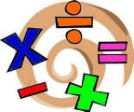   | Creative     | Thinking     | Healthy me    
First News newspaper and activities. On Teams a selection of activities will be included, that are related to this week’s edition of First News. Also a digital copy of the newspaper will be added.  Welsh – see Mrs Davies’ overview. | We will continue to develop data handling as the focus of the numeracy this week. Various tasks have been set through Teams and MyMaths. | Research a Victorian British artist and create a copy of one of their famous pieces of art.  Drop it into a powerpoint alongside the original. | Week 2 of Science  You should be well on your way to doing the Joseph Lister research and starting your investigation. You will need to do some research on a Victorian scientist and then carry out an investigation at home.  There is also an opportunity to use literacy and numeracy (percentages) within the tasks. You will have to be resourceful and organised. This task is very relevant in our current times. You will complete this assignment on Teams. History and science included in the same assignment. | PSE: Cultural Diversity Read the powerpoint about cultural diversity. Discuss the questions with a family member, before moving onto the next slide. Answer the questions (on the last slide), on the pupil response in Teams.  P.E: Street Dance Click on the link: Street Dance Masterclass - BBC Teach Watch the clips about street dance then try some individual street dance moves.  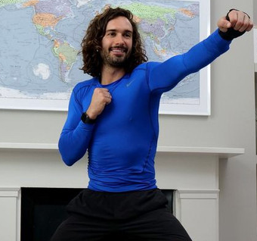  Joe Wicks Body Coach workout at 9am on Monday.  Tune in to You Tube>The Body Coach at 9a.m. every Monday, Wednesday and Friday to take part and stay active.
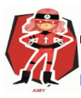  Ambitious  Capable  Learners | Ambitious  Capable  Learners | 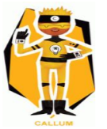  Enterprising  Creative  Contributors | Ambitious  Capable  Learners  Enterprising  Creative  Contributors | 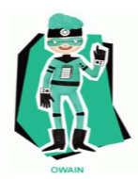  Healthy  Confident  Individuals  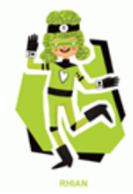  Ethical  Informed  Citizens

