  1 |  |  | Theme: Revolution  Year group: Y5/6  Week 4: 25/1/21 - 31/1/21
Literacy     | Numeracy  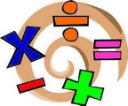   | Creative     | Thinking     | Healthy me    
This week's literacy involves creating your own non-chronological report. It's a bit of a cold write. Well a warm write because I've provided a Powerpoint with examples of non-chronogical reports from children and encyclopedias. I'm not saying these reports are good examples but they are creaative in their own way. There's also a checklist on the final slide.  Your challenge is to create your own non-chronological report on an aspect of Victorian Britain. It could be about school life, homelife, work life etc It could be more general and talk about general Victorian life. It's up to you. However I expect you to use your OWN words and not copy and paste text. That means you have to read what you research and write that in your own words in a design that's creative and has the features from the checklist. Details are on Teams.  Read the First Person Profile on Queen Victoria.  Try to translate it back to English so that it will make it easier for you to understand.  Use the online Welsh dictionary to help you with tricky words.  Create a Third Person Profile on Queen Victoria using your Welsh language patterns.  Remember a third person profile is when you write about someone else so you will need  to use patterns like:  Mae llygaid brown gyda Fictoria  Mae Victoria yn dwli ar reidio ceffylau  https://www.bangor.ac.uk/canolfanbedwyr/ap_geiriaduron.php.en  This is available on our Teams as an assignment. | Slightly different this week with maths. You are going to have to complete a maths lesson every day. There is a number of elements to complete. There is a link to a daily lesson where there is a video to watch and some activities to follow. On the the worksheet which is online after the lesson I'd like you to take a snip of the worksheet and drop it into a slide on Powerpoint in Teams and then use the draw tool to answer the questions. There is also some time work to do on MyMaths. You also need to be using J2blast regularly to improve your times tables. | Benjamin Britten – A New Year Carol  https://www.youtube.com/watch?v=MB7uwzJt0OM  Listen to the song using the YouTube link above  Research the composer and create a short PowerPoint presentation about him. Things you may want to consider are:  Where he was born and where he lived ?  What year he died?  What kinds of music did he compose?  Name some of his works (you could even listen to some of his other pieces and compare them)  Find some facts that you may find interesting and add them to your biography.  You can also find some pictures and add them to the biography.  This will be as a Teams assignment.  Mission 2:  Answer the questions about the song that you have been listening to using the editable PowerPoint attached to the assignment. | Science – please try and finish your investigation and all of the aspects of it. It’s the final week of the investigation so all slides need to be handed in by Sunday.  Watch the social reformers presentation. Think about what you already know about each of the figures featured in the video: Lord Shaftsbury, Robert Owen, Florence Nightingale, Sir Robert Peel, Elizabeth Fry, Octavia Hill and Thomas Barnardo. Try to explain why you think each reformer was important to historical change. See Teams for the details of the assignment.  R.E: Caring for our World. Looking after what is special to us. Look at each picture in the powerpoint, ‘What a wonderful world’. Complete the task at the end – what things in the world are special to you and why? | 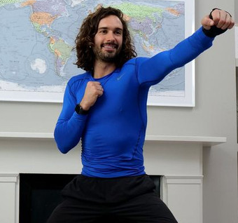  Joe Wicks Body Coach workout at 9am on Monday.  Tune in to You Tube>The Body Coach at 9a.m. every Monday, Wednesday and Friday to take part and stay active.  P.E: Rolling Towel Flip Challenge Click on the link, PE At Home: “Rolling Towel Flip” Challenge - YouTube Complete the challenge and let me know how many points you scored. Also, tell me what you liked about the challenge and how it helped you. The video will tell you how to make it more/less challenging. Good luck!
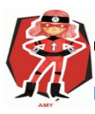  Ambitious  Capable  Learners | 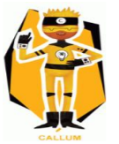  Enterprising  Creative  Contributors | 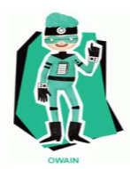  Healthy  Confident  Individuals | 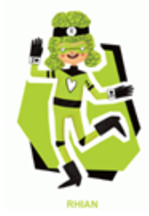  Ethical  Informed  Citizens | Healthy  Confident  Individuals

