  1 |  |  | Theme: Revolution  Year group: Y5/6  Week : 1/2/21 – 7/2/21
Literacy     | Numeracy  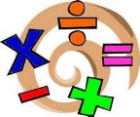   | Creative     | Thinking     | Healthy me    
Pobble 365 activity. Read the document carefully and then complete the activities.  On the first slide I'd like you to do the 3 activities.  1) Continue the story.  2) A day in the life.  3) Create a non-chronological report on penguins. (Doesn't just have to be about Emperor Penguins).  I want you to try these using different methods or Apps eg. Adobe, Powerpoint, Sway or anything else you can think of.  BE CREATIVE and uplevel your work.  You then have other activities on the following pages.  Present these using Word or Powerpoint.  Welsh – See Ms Davies’ Welsh planning sheet. | Similar this week with maths. You are going to have to complete a maths lesson related to graphs and data every day. There is a number of elements to complete. There is a link to a daily lesson where there is a video to watch and some activities to follow. On the the worksheet which is online after the lesson I'd like you to take a snip of the worksheet and drop it into a slide on Powerpoint and then use the draw tool to answer the questions. There is also some graph work to do on MyMaths. You also need to be using J2blast regularly to improve your times tables.  Don't forget when you're on MyMaths I'd like you to make sure you do the lesson as well as the homework. | Art is linked to our literacy and the Penguin theme. Follow the instructions on the Teams Assignment. | Geography  Continuing with our Penguin week, I'd like you to find out where each species of penguin can be found. Label them on the World map slide.  You could also add a table on one of the slides which gives data on each of the types of penguin.  Science  This week nearly all of the activities are related. From our literacy (Penguins) our science is going to be developed.  Your task is to plan an investigation from the information you gather and from the resources in Teams. (You do not have to carry out the investigation.... Just plan it)  To begin watch the clip on the link below from the BBC about peguins. You can read what it says underneath the clip but you don't need to do those tasks.  Next, open the powerpoint and read each slide carefully.  Your task is to answer and present your ideas using a Powerpoint or Word presentation. | PSE: Mental Health Week The resource, ‘My Wellbeing Challenge Booklet’ is for you to complete and keep. This is a good resource for you to look back on and to practice the strategies. Please let me know if it helped you how it helped you, this week.  P.E: Sock Keepy Ups Challenge  Click on the link, Weekly Challenge - Number 1 - Sock Keepy Ups! - YouTube Have a go at this challenge and let me know what you scored within a minute. To make it more challenging, use your knees or feet. Good luck.
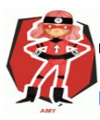  Ambitious  Capable  Learners | 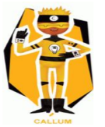  Enterprising  Creative  Contributors | 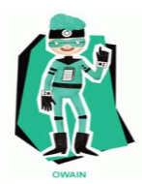  Healthy  Confident  Individuals | 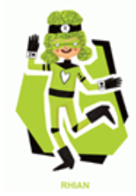  Ethical  Informed  Citizens

