  1 |  |  | Theme: Revolution  Year group: Y5/6  Week 8: 1/3/21 – 7/3/21
Literacy     | Numeracy  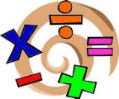   | Creative     | Thinking     | Healthy me    
Literacy – Explanation text comprehensions – See Teams.  As part of our drive to maintain, promote and engage pupil interest in reading, the school is celebrating World Book day on Thursday 4th March.  For our Key Stage 2 learners we ask for parents, carers and guardians to share photographs of the children dress up as their favourite book character with their teacher via Class dojo/ email. The dressing up possibilities are endless: Postman Pat, Oliver Twist, Fantastic Mr Fox, Charlie and the Chocolate Factory, James and the Giant Peach, Danny- Champion of the World, Matilda, Goldilocks, Jack and the Beanstalk, The Twits, Cinderella, Gruffalo, Elmer the Elephant, Three little Pigs, Harry Potter etc  Welsh resources See Miss Davies’ lessons and assignments. | Numeracy – Calculations series of 5 lessons on 3d shape to be accessed via Teams.  https://login.mymaths.co.uk/login | As it's Welsh week I'd like to see you draw your own dragon. I would like it to be very detailed and well drawn. Use whatever resources you have. I expect good quality drawings off the class this week. I've included 2 tutorials for you to watch or look for your own. | Welsh week history – take a virtual tour of 2 of Wales’ most famous castles: Castell Coch and Raglan Castle.  https://cadw.gov.wales/cadws-open-doors-online-castles-south.  Tell me which is your favourite and why and also try to present a shorter tour of your favourite parts of the tours on Powerpoint. | For this assignment I'd like you to create a non-chronological report on Fair trade. Think about all the features of a non-chronological report and try to include them in your Fairtrade report. Remember to use your OWN words and NOT copy and paste everything. Good luck and I look forward to reading them.  Present it as you see fit.
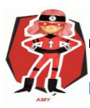  Ambitious  Capable  Learners | 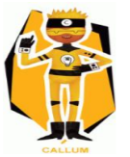  Enterprising  Creative  Contributors | 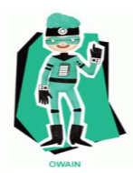  Healthy  Confident  Individuals | 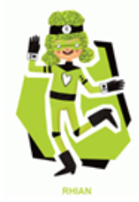  Ethical  Informed  Citizens

