 |  |  | Theme: Revolution  Year group: Y5/6  Week 9: 8/3/21-14/3/21
Literacy     | Numeracy     | Creative     | Thinking     | Healthy me    
Literacy:  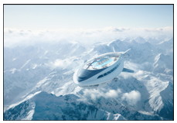  Air Hotel 3000  It is the year 3000, and the new ‘Air Hotel 3000’ is embarking on its maiden trip!  Can you write an explanation text for this new type of hotel? It might be a poster or a leaflet.  You’d need to describe it’s features and also how it works.  Think about the following:  What features do you think this new type of hotel has?  How is it similar/different to hotels/holidays we go on today?  How many people do you think can travel on the Air Hotel 3000?  Where do you think it might be heading on its voyage?  Who is flying it? How is it controlled?  How do you think the hotel is powered?  How do you think it lands?  See Teams for assignment.  Welsh Mission – See Mrs Davies’ Planning. | Numeracy :  Design and make your own 3D shape. You’ll need to create a 2d net then accurately cut out and fold together to make your 3d shape. (be careful cutting out) You’ll need to name your shape, number of edges, faces and vertices. You could even create a table with more than one 3d shape.  See Teams for assignment. | Music – See Miss Davies’ planning. | Science Week – A series of 6 lessons for learners to try at home.  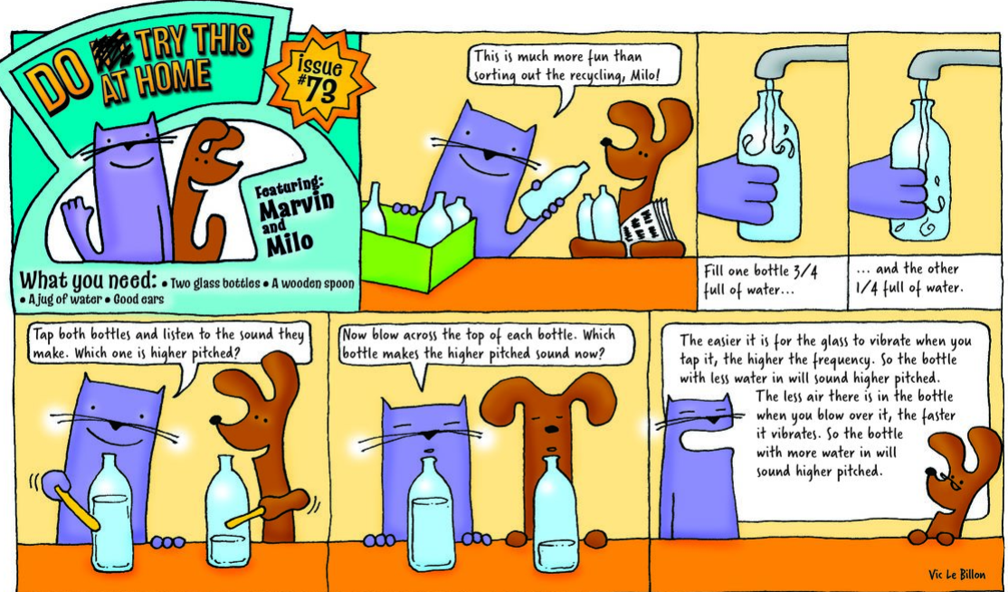  Access assignments via Teams and record to the best of your ability on the Powerpoint within your assignment.  See Teams for assignment.  History - Look at images of Victorian inventions. Work online to find out the dates of each invention and order them on a digital timeline using software, such as PowerPoint or Excel. Encourage the children to import images onto their timeline, as well as dates, captions, hyperlinks and audio or video links to explain the importance of each invention. Find out who invented each item and write a brief few sentences about them. Inventions could include the first purpose-built transatlantic steamship, a home-use sewing machine, the first telephone call, the first practical incandescent light bulb, the first photographs, the first petrol motor car and the first jelly babies!  Use the Powerpoint Template and change accordingly or be inventive and create your own.  See Teams for assignment.  Geography/History:  In this assignment I want you to compare how Morriston looked years ago during Victorian Times compared with how it looks today. If you click on the link below it shows a website that has a slider over the map and if you slide the button to the left the Victorian map appears over the current day map.  https://bit.ly/3bQpBXf  See Teams for assignment.  R.E: Why is the Bible important to Christians? Watch the clip: Religious Studies KS2: The Holy Bible - BBC Teach Read the powerpoint Bible story of Daniel in the Lion’s Den. Using the pupil response in Teams Assignments, answer these questions: 1). What themes are in the story?  2). Give three reasons why you think this is Nathan’s favourite story? Think about how the Bible helps Nathan. | P.E: Gymnastic movements Clck on the link: Year 6 PE Monday 1st February - gymnastics lesson 2 - YouTube Have a go at the two gymnastic challenges. Record your movements using Flipgrid: https://flipgrid.com/4076927c  If you have any questions/problems, email me: wattss11@hwbmail.net. You can also send me a message on Teams. All resources will be in Teams Assignments and Class Materials in Files, in Teams.
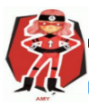  Ambitious  Capable  Learners | 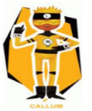  Enterprising  Creative  Contributors | 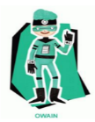  Healthy  Confident  Individuals | 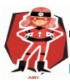  Ambitious  Capable  Learners |   Ethical  Informed  Citizens

