  1 |  |  | Theme: Revolution  Year group: Y5/6  Week 11: 22/3/21 – 25/3/21
Literacy     | Numeracy  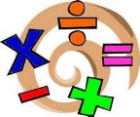   | Creative     | Thinking     | Healthy me    
Literacy Mission ( 2 weeks) – Researching old Victorian words and phrases that have gone out of fashion. Create a glossary  Back to school week – Literacy in class – explanation texts – Comprehensions, sentence and word level work and create own invention ready for an explanation write.  Welsh – See Ms Davies’ | Numeracy Mission (2weeks) - Look at Victorian coinage and currency. Complete the task associated.  Numeracy – White rose maths led lessons on ratio and proportion. LA – further work on fractions. This unit will continue for 2 weeks. | Creative Mission (2weeks) - During a visit to the Tabernacle Chapel on our school’s 150th anniversary, there were beautiful stained glass windows. Some of these were to commemorate the loss of life during WW1.For your Creative Mission I would like you to re-create a stained glass window using ArtRage on the i-pads. Research some Victorian stained glass windows and then you could:- Either drop the image into ArtRage and trace over the top using the layers function or create your own stained glass window from scratch on ArtRage.  Music see Ms Davies’ | Thinking Mission (2weeks) - Thinking: One child in your group will open a Powerpoint and share it with the other 2 in their group. The objective is to create a joint presentation on an aspect of the Victorians. This will be on famous or important Victorian inventions. Include in your work an explanation of how the invention works and why it is so important or famous. This is a joint task and each member of the group needs to contribute to the final presentation. Include me as part of the shared presentation.  Digital mission (2 Weeks) – Using Minecraft education create a Victorian Town or aspects of it. You could include the slum areas, a workhouse, a school a manor house etc…. Don’t forget you need to include information from authentic Victorian times so some research will be needed. You need to be very creative and be able to present back to me – and I have no idea about minecraft.  Focus – Science - 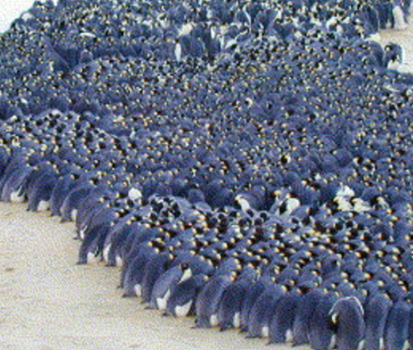  Why do penguins huddle investigation?  Full investigation to replicate above statement.  Week 1 – 2– Carefully carry out the investigation and record the results. Write a conclusion based on the results and link to similar situations.  Focus – ICT  Looking at spreadsheets.  Creating spreadsheets and producing graphs. Will use as lead up to reporting the science investigation. Use the spreadsheets to back up the data collected and graphed from the science. | PE – Whole class – Cricket and rounders skills (continued from last week) – We’ll look at throwing, catching and retrieving skills this week. Skills focus this week with small sided games ready for the summer term. Differentiated by outcome and support needed.
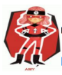  Ambitious  Capable  Learners |   Enterprising  Creative  Contributors  Ambitious  Capable  Learners | Enterprising  Creative  Contributors  Ambitious  Capable  Learners | 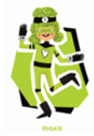  Ethical  Informed  Citizens  Enterprising  Creative  Contributors  Ambitious  Capable  Learners | 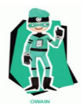  Healthy  Confident  Individuals

