  1 |  |  | Theme: Revolution  Year group: Y5/6  Week 8: 01/03/21 – 05/03/21
Literacy     | Numeracy  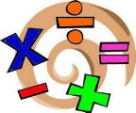   | Creative     | Thinking     | Healthy me    
PSE: Citizenship – Our Community.
Think about the area you live in. Would you change anything to improve it?
Complete the resource, ‘Our Community’.
Using your ideas on the sheet, write to our local councillor, Cllr Andrea Lewis to tell her about your ideas and suggestions to improve the area you live in.

Success Criteria:
1). Write your address and date on the right side of the page.
2). Write in a formal tone. Begin the letter with,
‘Dear Cllr Lewis’,
3). Write a new paragraph for each new idea/suggestion.
4). Give reasons why you want to see these improvements.
5). End your letter with,
‘Kind Regards’ then your name underneath.
Look at the example resource to help you.

P.E: Gymnastic movements
Watch and follow the instructions on the powerpoint.
Record your movements using Flipgrid:
https://flipgrid.com/80eb1244
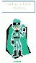

If you have any questions/problems, email me: wattss11@hwbmail.net.
You can also send me a message on Teams.

All resources will be in Teams Assignments, Class Materials in Files, in Teams and on the class webpage.

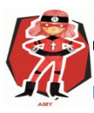  Ambitious  Capable  Learners | 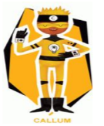  Enterprising  Creative  Contributors | 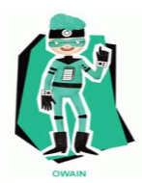  Healthy  Confident  Individuals | 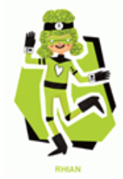  Ethical  Informed  Citizens

