  1 |  |  | Theme: Revolution  Year group: Y5/6  Week 8: 15/03/21 – 19/03/21
Literacy     | Numeracy  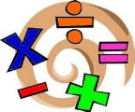   | Creative     | Thinking     | Healthy me    
 |  |  | R.E: The Easter Story  Split into two parts, read through the Easter Story powerpoints and complete one of the accompanying tasks.  You can use the pupil response to record your work.  Remember:  To give your work a title.  Type/copy and paste the question you want to answer.  Record your answer. | P.E: Multiskills  Use the resource to play, ‘Funky Fives’.  If you have any questions/problems, email me: wattss11@hwbmail.net.  You can also send me a message on Teams.  All resources will be in Teams Assignments and Class Materials in Files, in Teams.
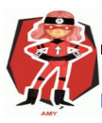  Ambitious  Capable  Learners | 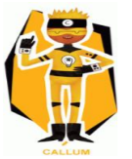  Enterprising  Creative  Contributors | 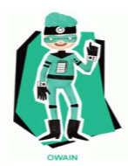  Healthy  Confident  Individuals | 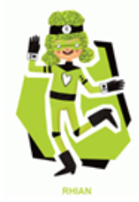  Ethical  Informed  Citizens

