
Templed Gweithgaredd Cymraeg /Welsh Mission Template 

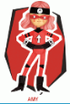
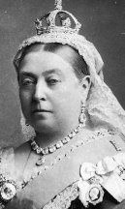
Read the Queen Victoria First Person Profile and Comprehension
Answer the question correctly in Welsh (you can use your Year 5/6 language patterns
to help)
Write your answers in full sentences for example:
Pa liw llygaid sydd gyda ti? Mae llygaid brown gyda fi

There may be some words in the profile that you do not understand, therefore you can use the Welsh dictionary app or website.
https://www.bangor.ac.uk/canolfanbedwyr/ap_geiriaduron.php.en

Queen Victoria Loop Game
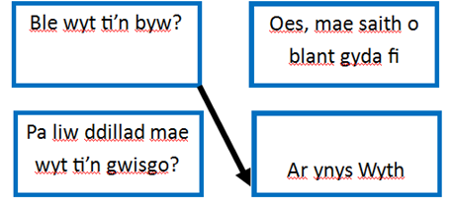
Connect the questions to the correct answers by drawing a line from each one.
You will need your language patterns and the comprehension to complete this.



