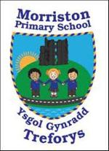
Year 5/6 – Summer Term – ‘Hola Mexico’
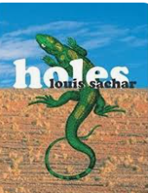
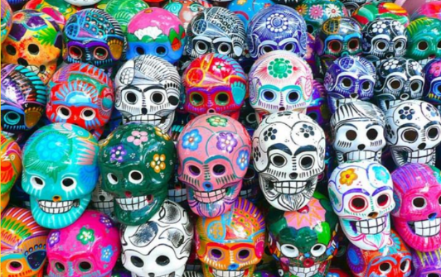

Dear Parents,
Can I begin by welcoming you to the new term. I am looking forward to working with you to give the children the opportunity to be the best they can be.
In the Hola Mexico project, children will experience what life is like in Mexico. Bienvenido a Mexico! We’re going to explore this unique country, from its towering temples to its fun-packed festivals.
During this half term, we’ll watch a traditional Mexican performance and join in with percussion instruments. To cool down afterwards, we’ll have a refreshing drink of sangrita or limeade. We’ll use non-fiction books to find out about the importance of music in Mexican culture and have a go at folk dancing. Using our literacy skills, we’ll write about festivals and create an invitation to a Mexican food tasting session. In preparation, we’ll make delicious drinks and savoury dishes. We’ll learn about the ‘Day of the Dead’ and create 3-D skulls. With the Chihuahuan Desert as our imagined location, we’ll write postcards. We’ll read Maya myths and legends, and write our own. Using maps, we’ll locate Mexico and explore its natural features. We’ll discover what daily life is like and how it has changed over time. Then we’ll craft Maya chocolate and simple woodwind instruments from recycled materials. Who can make the highest, loudest and longest sounds?
Our Class Novel this term is ‘Holes’ by Louis Sachar and we’ll empathise with the characters within the story.

More information on EmpathyLab can be found at: www.empathylab.uk

Please take some time to discuss/work with your child to discuss possible learning / questions they would like to find out during the topic ‘Hola Mexico’. These ideas will aid future planning during the Summer Term.
For most of our pupils it will be their last term in primary school before they transition to comprehensive. We will continue to strive to ensure our learners become the best they can be and are ready for their next stage of education.
Possible learning / questions to explore

Thanking you in anticipation,
Mr Bendle & Year 5/6 staff

