  1 |  |  |  | Theme: Beast Creator  Year group: Year 5/6  Date: 13/7/20
Literacy     | Numeracy  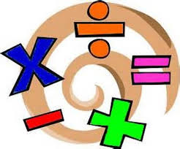   | Creative     | Thinking     |  | Healthy me    
This week we are going to continue with Rising Stars Reading Planet.  The children will be assigned 3 more books for the summer holidays to complete which will contain comprehension quizzes throughout.  They will look at trying to complete the book ready for the start of the summer term. | Different tasks will be set for completion over the summer holidays. A range of maths areas will be selected.  MyMaths learning platform will be used. | Leaver’s dance – Create your own dance to an appropriate piece of music which can represent a celebration of the Y6s moving up to comprehensive school. For the Y5s your moving to the top of the school make your dance represent that or for your friends that are leaving. Don’t forget the music needs to be appropriate. | History – Ask your parents/grandparents/aunties and uncles what their experience of going to comprehensive school was like. What was the same/different about their experiences? Research when was the first comprehensive school? What was there before? Think carefully about how your going to present your work. |  | Transition – What are your targets for next year? What are you going to improve about your learning? What parts of your schooling, both at home and school, do you want to improve?  PE – Over the summer holidays plan how you’re going to keep fit and healthy – create a fitness plan. What are your goals for keeping fit and heathy? What new sports and activities would you like to try out from September?

