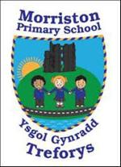
Year 5/6 – Autumn Term – ‘Gallery Rebels’
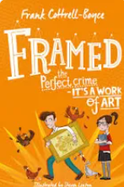


Dear Parents,
Can I begin by welcoming you to the new term. I am looking forward to working with you to give the children the opportunity to be the best they can be. I will detail expectations and how we work when we ‘Meet the Parents’ in a couple of weeks. I’ve outlined below a brief synopsis of what our theme is so you can help support the learners.
This term the children will learn about significant artists and artistic movements, covering the impact of society on art and begin to master new painting and drawing skills.
Linked science investigation: Is green really green? What colour are shadows?
Colours collide, melting together on the canvas: an impression of light, a rage of red, a lobster perched on a telephone. Come and find out about the bizarre and eccentric minds of the gallery rebels. Art can be an act of rebellion. Can you change the world with a paintbrush, a thought, or an idea? Dream the dream, or show us your nightmares. What do you see? Watches melting? Wheels spinning? A shark in a box? Can you express yourself without words? Well, a picture paints a thousand of them. Paintbrushes and sketchbooks at the ready. Let’s make art.
As you can see there will be a range of opportunity to be creative this term.
Our Novel this term will be ‘Framed’ by Frank Cottrell-Boyce. We will be using this novel to develop our empathic skills via the EmpathyLab model.

More information on EmpathyLab can be found at: www.empathylab.uk

Please take some time to discuss/work with your child to discuss possible learning / questions they would like to find out during the topic ‘Gallery Rebels’. These ideas will aid future planning during the Autumn Term.
For most of our pupils it will be their last year in primary school before they transition to comprehensive. We will continue to strive to ensure our learners become the best they can be and are ready for their next stage of education.
Possible learning / questions to explore

Thanking you in anticipation,
Mr Bendle & Year 5/6 staff

