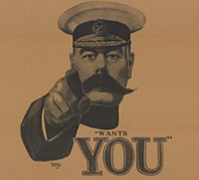
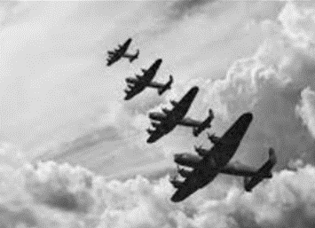
Britain at War
Over the next term, Year 5&6 will be learning about WW1 and WW2.
In the grid below, you will find many interesting activities for you to complete at home. Choose one activity each week to complete in your homework book. Your book will need to be returned to school every Thursday for the class reflection time where homework will be displayed and shared with class peers.
Literacy, Languages and Communication  Discuss with a family member what the words ‘conflict’ and ‘war’ mean and look up their meaning in a dictionary. Then use a dictionary to write definitions for the terminology below:  Alliance, invasion, expansionism, militarism, fascism, nationalism, imperialism, retaliation | Science and Technology  Make do and mend! Can you revamp some of your old clothes to make new clothes? Maybe you could ‘upcycle’ some unwanted household items to make them useful in a whole new way! Bring them to school to show your classmates and share your ideas. | Expressive Arts  Choose a vehicle from either of WWI or WW2 and complete a detailed drawing or painting of it. Be creative and determined.  Write a few sentences on why you chose this vehicle. | Numeracy  Create an information text or table looking at the World wars in numbers.  For example:  15000 Welsh men were killed in the war.  Look for informative numers.
Humanities  Use a range of sources to look at images of First World War trenches. Find out about trench warfare and then answer the questions. • Why were trenches used during the First World War? • What did trench warfare involve? • What was life like for the soldiers in a First World War trench? | Humanities  Britain and its inhabitants have fought in or endured several significant conflicts throughout history. Use a range of sources to find out about the conflicts listed and Britain’s involvement. Record your findings in a table. Include the following column headings: name of conflict, date, countries or people involved, one major cause and one major consequence of the conflict.  • Norman Conquest of England • Wars of the Roses • English Civil War • Napoleonic Wars • Crimean War • First World War • Second World War | Literacy, Languages and Communication  Use your existing knowledge and a range of sources to write a report about the First World War. Record information as notes on a mind map first, under headings such as causes, warring nations, key events, front line, home front and how the war ended. Use your mind map to help you write your report. Include a title, an opening paragraph, a timeline of key events, subheadings, detailed facts, precise topic vocabulary and images with captions. | Humanities  The Ministry of Information produced persuasive posters during both the First and Second World Wars to affect people’s opinions and actions. Use online sources to learn more about wartime posters and to find examples. Then answer the questions. • What was the purpose of persuasive posters in the First and Second World Wars? • Propaganda was a feature of some wartime posters. What is the definition of the word propaganda? • In what different ways did posters encourage British people to get involved in the war effort during the First and Second World Wars? • Choose some wartime posters to explore and answer these questions: Who was the poster aimed at? What was it meant to achieve? How effective do you think it was and why?
Literacy /Humanities  Experts developed different weapons, innovations and technology during the First and Second World Wars to help each side defeat their enemies. Examples include artillery, aircraft and radar. Find out about the weapons, innovations, and technology developed, then create an information poster about one development that interests you. Include a title, images with captions and detailed facts. |  | Expressive Arts  Research any famous paintings that depict war. Who painted them? When? Present this in a Powerpoint or as an information text.

