Year 5/6 – Spring term topic – ‘BloodHeart ’
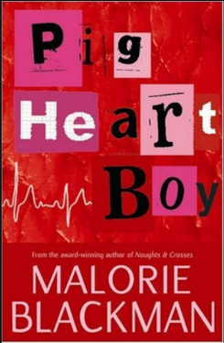
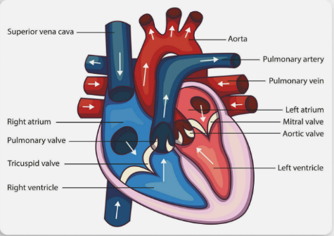
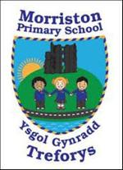

Bloodheart is a science based project that involves looking at depth at our hearts and the importance of keeping them healthy.

At the start of our project we’ll look at anatomical drawings and videos on the heart. We will then dissect an animal heart, finding out about the different parts and how the blood flows comparing to our knowledge of the anatomical drawings and videos. Afterwards, we’ll write a non-chronological report on the Heart and its connotations throughout the AoLEs. We’ll use a data logger to measure our heart rates and test how it is affected by exercise. As part of our music work, we’ll use our bodies as percussion instruments and feel our pulse. We’ll read shape poetry, and write poems inspired by the heart. We’ll learn about how smoking affects the heart and write adverts to persuade people to stop smoking. We’ll visit the ‘Give blood’ website, and make a flow diagram to illustrate the circulation process.

This term our class novel is ‘Pig Heart Boy’ by Malorie Blackman. I would appreciate it if the children don’t read the novel beforehand as we want to discover themes and discussion points together. We will be using this novel to develop our empathic skills via the EmpathyLab model.

More information on EmpathyLab can be found at: www.empathylab.uk

Please take some time to discuss/work with your child to discuss possible learning / questions they would like to find out during the Bloodheart Project topic. These ideas will aid future planning during the Spring Term.
Possible learning / questions to explore

Thanking you in anticipation,
Mr Bendle & Year 5/6 staff

