  1 |  |  | Theme: Blood Heart  Year group: Y5/6  Week 2:
Literacy     | Numeracy  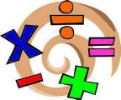   | Creative     | Thinking     | Healthy me    
Literacy:  The heart is an important organ of the body but it is used to describe feelings and emotions in life generally.  Write a poem that uses the heart to express feelings. It can be a rhyming poem if you like or some other form of poem. Perhaps you can use an idiom or saying that uses the heart as a stimulus (idea for your poem). | Numeracy:  Research the sizes of the largest and smallest hearts in the Animal kingdom as well as humans. Perhaps you could see which beats the fastest/slowest.  Put these into a table and perhaps a graph. Make sure your presentation is excellent and use graph paper if needed. | Creative:  Use ready mix paint or other materials in different shades of red to create abstract art paintings. Use whatever resources or tools that are available to you. No larger than A3. Think about what you are trying to represent – are you going to use symmetry, textures, or any other techniques. | Thinking:  Research the heart and its function (What does it actually do?). When was the first heart transplant? Was there a famous Welsh person who had a heart transplant? Find out.  Think about how you’re going to present your work – It must be the highest quality work.  Digi Mission : We are going to learn how to code using scratch 3.  https://projects.raspberrypi.org/en/projects/rock-band  Remember to persevere and follow the instructions. Take screen shots and put into some powerpoint slides to show your programming ability. | Health and Well-being:  Create a Monday to Friday healthy timetable to help maintain a healthy heart. You’ll need 3 meals a day plus a variety of exercises to add to your timetable. Make sure your timetable is neatly presented in your mission book.
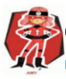  Ambitious  Capable  Learners |  |   Enterprising  Creative  Contributors | 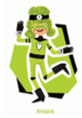  Ethical  Informed  Citizens | 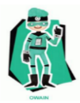  Healthy  Confident  Individuals
WWW – What went well?
EBI – Even better if …
My friend thinks –


