  1 |  |  | Theme: Blood Heart  Year group: Y5/6  Week 2:
Literacy     | Numeracy  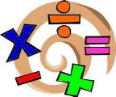   | Creative     | Thinking     | Healthy me    
Literacy:  Create an information leaflet on the dangers of smoking and the effect it can have on the heart.  Think about financial, health, anti-social and life expectancy. | Numeracy:  Create a timeline of significant events in heart surgery and treatment. | Creative:  Model a heart from clay or plasticine, using photographs taken during the dissection to help them sculpt. Use their sculpture to explain how the heart works.  Note: Real medical students do this activity to understand the structure and functioning of the heart. | Thinking:  A healthy heart is the key to survival.  If you were shipwrecked and washed up on a deserted island what would you take with you? Diamond rank the things you would take and explain why.  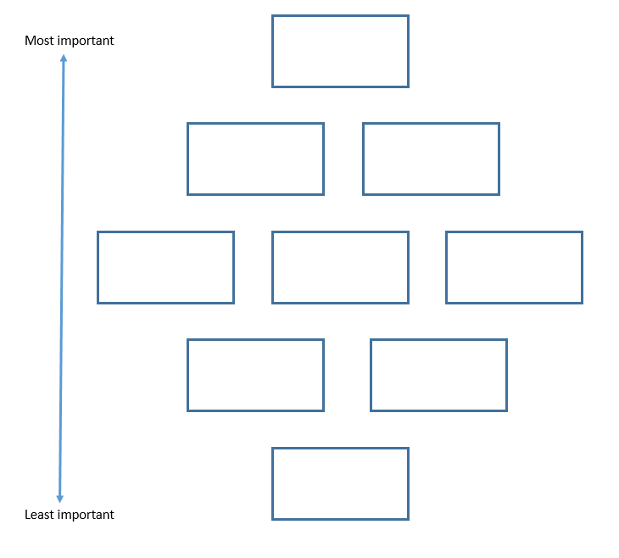  Digi Mission.  Using J2code, use logo to experiment with angle and shape. See if you can create an interesting design.  You may need to email the code and the design to me. | Health and Well-being:  Create a circuit of fitness that can be carried out in class. It must be able to exercise all body parts and make use of the area around where you sit. (You obviously can’t run around class) Think about easy, moderate and hard exercise to cater for everyone.
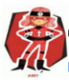  Ambitious  Capable  Learners |  | 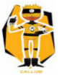  Enterprising  Creative  Contributors | 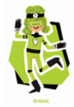  Ethical  Informed  Citizens | 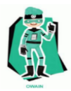  Healthy  Confident  Individuals
WWW – What went well?
EBI – Even better if …
My friend thinks –


