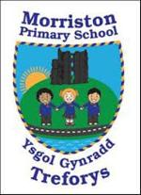
Year 5/6 – Autumn Term – ‘Revolution’
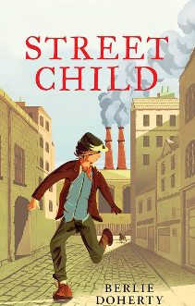
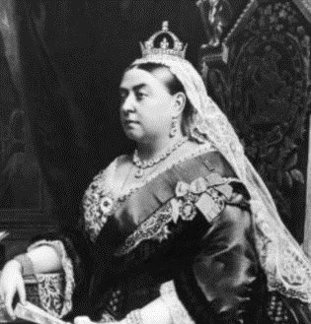

Dear Parents,
Can I begin by welcoming you to the new term. I am looking forward to working with you to give the children the opportunity to be the best they can be.
In the Revolution project, children will experience what life was like in Victorian times and compare it to life today. They will learn about the living and working conditions that many Victorian children had to endure and they’ll learn about the inspirational Dowlais schools in Merthyr Tydfil. The conditions in Victorian slums and workhouses will make them wince as they compare the lives of the poor to the lives of the rich. They’ll learn about famous Victorians, for example Alexander Graham Bell, Robert Peel, Lord Shaftsbury, Elizabeth Fry, Joseph Lister, Doctor Barnado and William Morris to name but a few. Using their historical enquiry skills, they’ll explore and identify Victorian objects and learn about a range of new inventions, such as the telephone, the transatlantic steamship and photography. At the end of the project, they will share their learning and answer the question ‘What did the Victorians do for us?’
Our Novel this term will be ‘Street Child’ by Berlie Doherty. We will be using this novel to develop our empathic skills via the EmpathyLab model.

More information on EmpathyLab can be found at: www.empathylab.uk

Please take some time to discuss/work with your child to discuss possible learning / questions they would like to find out during the topic ‘Revolution’. These ideas will aid future planning during the Spring Term.
For most of our pupils it will be their last year in primary school before they transition to comprehensive. We will continue to strive to ensure our learners become the best they can be and are ready for their next stage of education.
Possible learning / questions to explore

Thanking you in anticipation,
Mr Bendle & Year 5/6 staff

