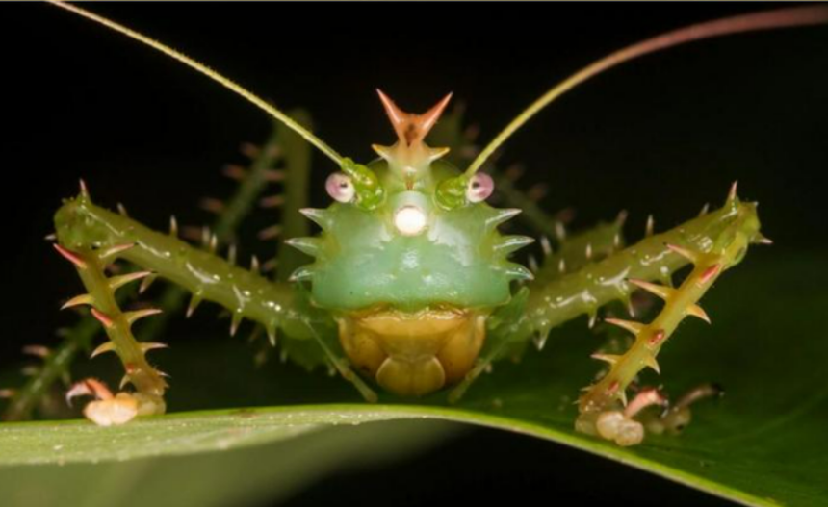
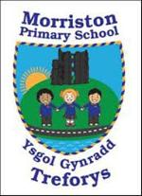
Year 5/6 – Summer term topic – ‘Beast Creator’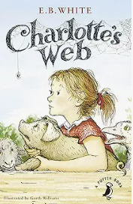

Our topic this term is ‘Beast Creator’. The topic has a science focus relating to animals and their environments. Pupils will be using their science skills to investigate types of creatures that live in our grounds and the wider world. They will be comparing countries and habitats that have ‘dangerous beasts’. Children’s art skills will improve as they make detailed observational drawings, using botanical/natural history images for inspiration. Children will explore food webs and life-cycles. Maps will help pupils to identify the places/habitats.
This term the class will be reading Charlottes Web by E.B. White. We will be using this novel to develop our empathic skills via the EmpathyLab model.

More information on EmpathyLab can be found at: www.empathylab.uk

Please take some time to discuss/work with your child to discuss possible learning / questions they would like to find out during the topic ‘Beast Creator’. These ideas will aid future planning during the Summer Term.
For most of our pupils it will be their last term in the school before they transition to comprehensive. We will continue to strive to ensure our learners become the best they can be and are ready for their next stage of education.
Possible learning / questions to explore

Thanking you in anticipation,
Mr Bendle & Year 5/6 staff

