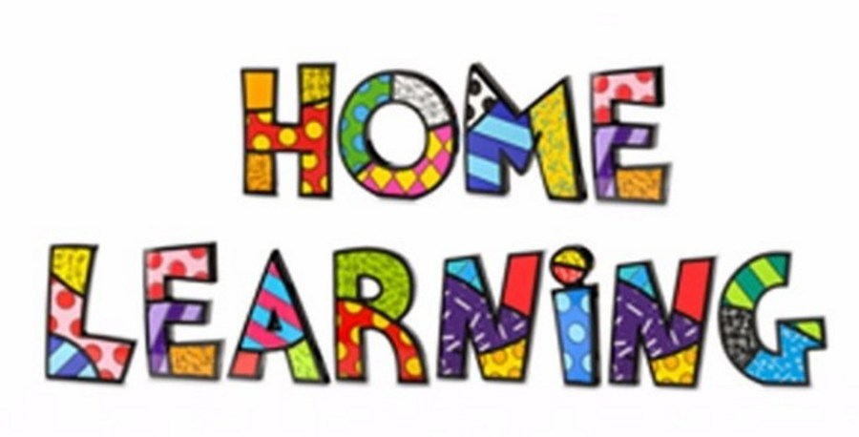

Week 1
Literacy:- Letter J. This week pupils are to work on the letter J. Find different objects that begin with the letter. Letter J song. https://www.youtube.com/watch?v=Slu-XafZ6Ww
Mr Tumble Alphabet song https://www.youtube.com/watch?v=mMog84sQp3o

Maths:- Number recognition. To recognise numbers 0-10. Number songs. Counting objects.
Number songs - https://www.youtube.com/watch?v=dk9Yt1PqQiw
Number blocks on the internet are also a good resource.
Ideas:- Practice forming the letters and numbers in a range of multi sensory approaches.
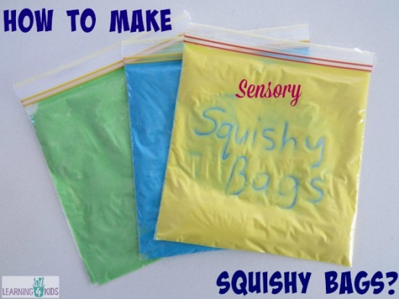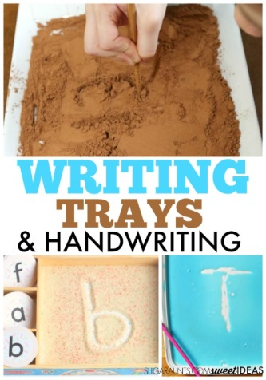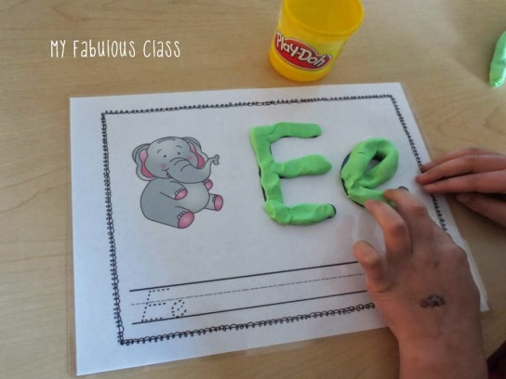
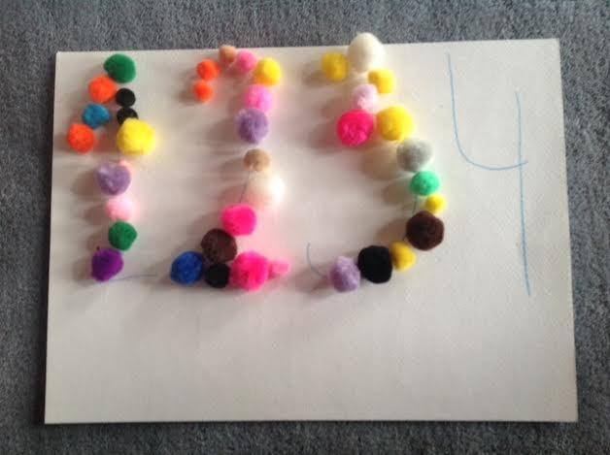
Challenges
Week 1
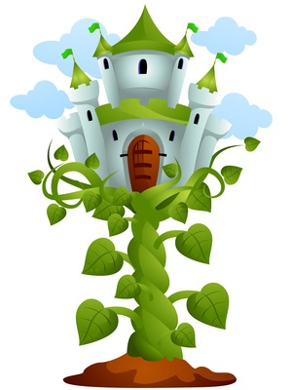
Build a beanstalk using a range of junk material. Once finished measure the beanstalk using non-standard units.
Ideas to measure
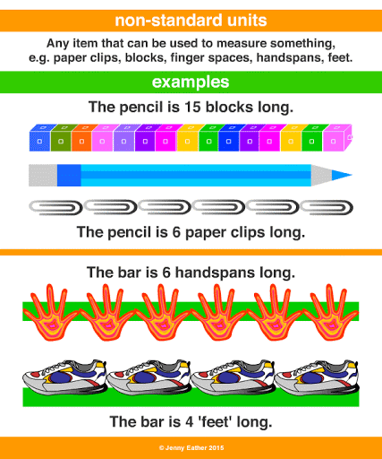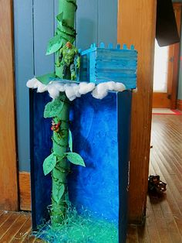
RWI Sessions daily online.



