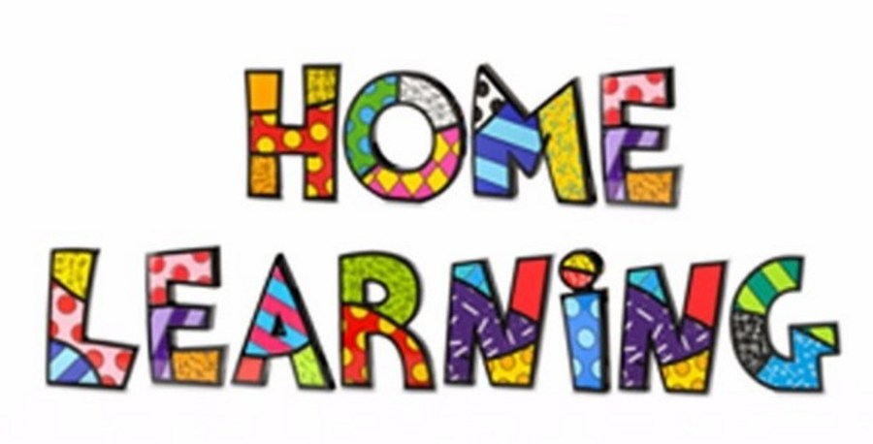

Week 8 – 18.5.2020
Task 1
Literacy: - Letter m. This week pupils are to work on the letter, m.
Letter m song - https://www.youtube.com/watch?v=UrQdvmgFhVs
Mr Tumble Alphabet song https://www.youtube.com/watch?v=mMog84sQp3o
Read Write Inc. have now announced that their resources are free. Click on the linked below.
https://m.youtube.com/channel/UCo7fbLgY2oA_cFCIg9GdxtQ
This link allows you to download resources. Scroll down to the letter, which we are learning. https://home.oxfordowl.co.uk/reading/reading-schemes-oxford-levels/read-write-inc-phonics-guide/
Use the link below to practice the RWI sounds in the daily sound book.
https://www.oxfordowl.co.uk/api/interactives/29318.html
Complete the worksheets attached to the website.
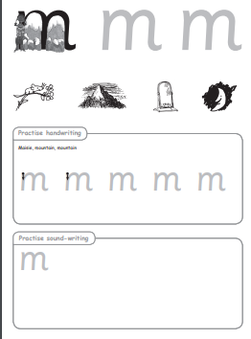

Practice writing the letter in different multisensory ways
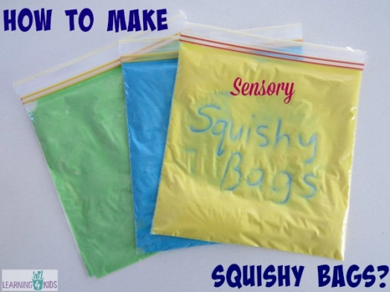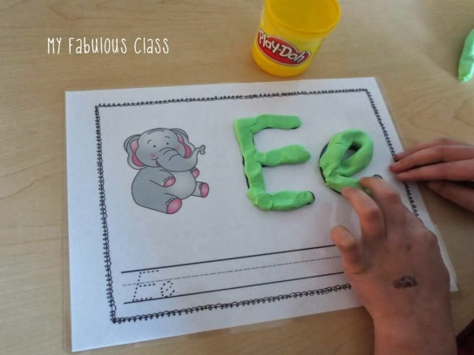

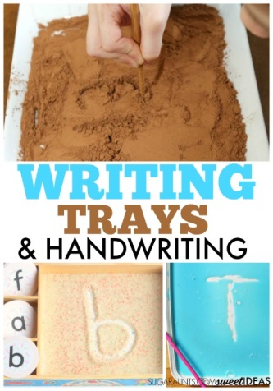
Task 2
Writing your name
Practice writing your name in a range of multisensory ways.
Task 3
Pencil control
Continue to practice your pencil control. Templates are on the webpage.
Task 4
Reading
Listen to the story ‘Owl Babies’’. You can find the story on the link below
https://vimeo.com/55971653
Using the colourful semantic card, discuss who is in the story. Can the pupils name the characters in the story? Pupils to point to the characters on request and repeat their names. Draw and make special marks to represent the characters. Name the owls, Sarah, Percy and Bill. Who is in the owl family?
Parts of an owl
Ask the pupils to point to the different parts of the owl. Name the parts on request.
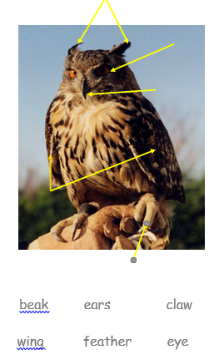

Maths: - Measurement
Order the owls in size. Largests to smallest. You could make your own owls.
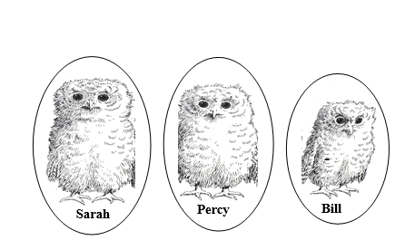
Maths: - Number recognition. To recognise numbers 0-10. Number songs. Counting objects. Practice forming the numbers. How many birds can you find in the garden?
Number songs - https://www.youtube.com/watch?v=dk9Yt1PqQiw
https://www.youtube.com/watch?v=5dqGDSOMHRo
Ideas: - Practice forming the numbers and numbers in a range of multi-sensory approaches.
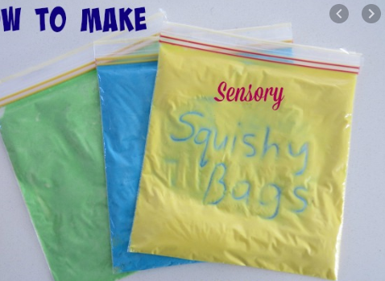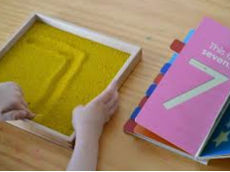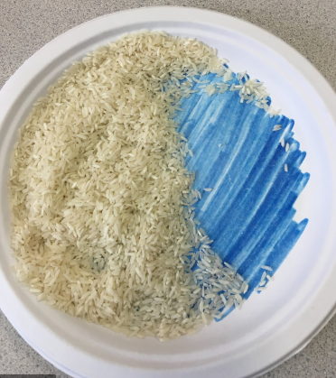

Can we focus on the formation of number 3 this week. I have attached some worksheets to help. However, you can form the number in sand, rice, paint, chalk or any other materials. You could even use your child’s favourite cereal.
Order the trees
https://www.oxfordowl.co.uk/api/interactives/24487.html
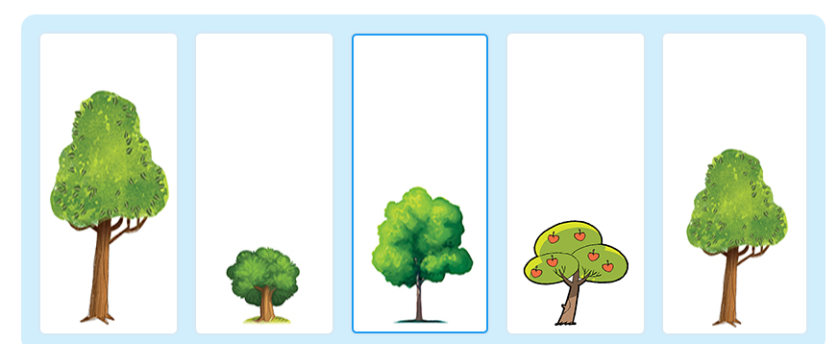
h
Challenges
Week 7
Challenge 1
Make your own Owl Babies pictures.
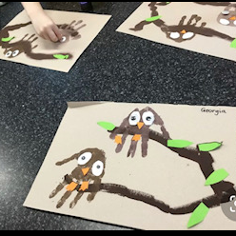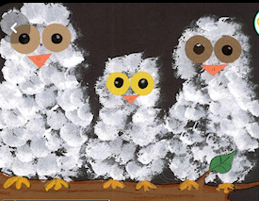
Challenge 2 – Owl biscuits
Have fun cooking with your parents and make some owl biscuits.
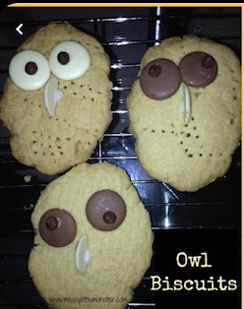
Challenge 3
Go Bird watching! What birds do you find in your garden? Take photographs and post them on Dojo.
Challenge 4
Day and night
Sort the activities that you do into day and night.
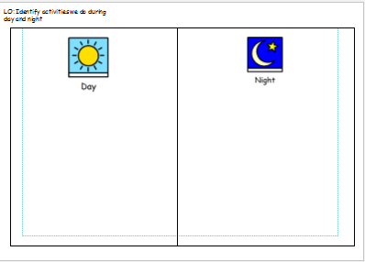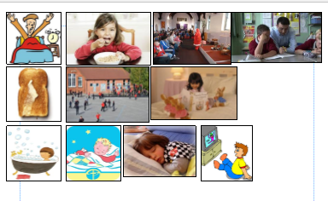

P.E. Challenge:
Join in with Joe Wicks PE 30 min a day via YouTube live every morning at 9am (Mon-Fri). Alternatively, go on a 30 min walk everyday but stay safe.

Numeracy Challenges
Play games on the following websites, particularly working in number skills such as place value, addition and subtraction
www.topmarks.co.uk
Go outside, draw your numbers using chalks, and count the correct amount of objects.
Make a big number 3 using outdoor materials.

