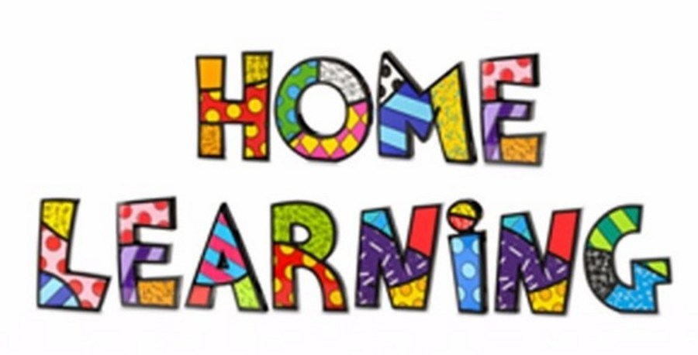

Week 2
Literacy:- Letter V. This week pupils are to work on the letter V. Find things that begin with V.
Letter v song. https://www.youtube.com/watch?v=gOzHf_2YxGg
Mr Tumble Alphabet song https://www.youtube.com/watch?v=mMog84sQp3o
Easter Story
Read the Easter Story found on http://www.communication4all.co.uk/http/Easter.htm. Use the colourful semantic cards ‘Who’ and ‘what doing’. Talk about who is in the picture and what are they doing.
Draw a picture from the story and overwrite/mark make key words.

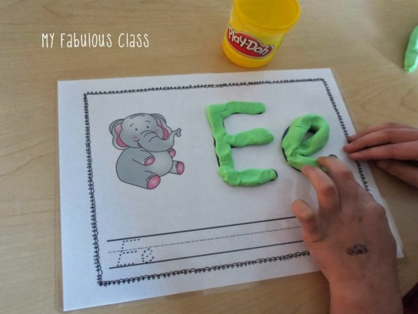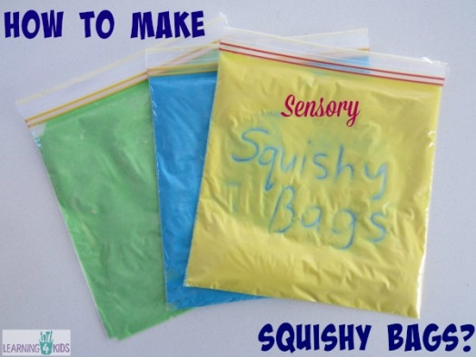

Maths:- Counting objects numbers to 1-10. To recognise numbers 0-10. Number songs. Counting objects.
Number songs - https://www.youtube.com/watch?v=dk9Yt1PqQiw
Topmarks counting games - https://www.topmarks.co.uk/maths-games/3-5-years/counting
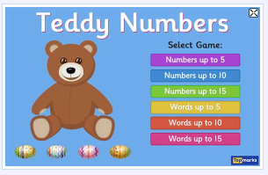
Whiterose Maths is a lovely resources with ideas. https://whiterosemaths.com/homelearning/
Ideas:-

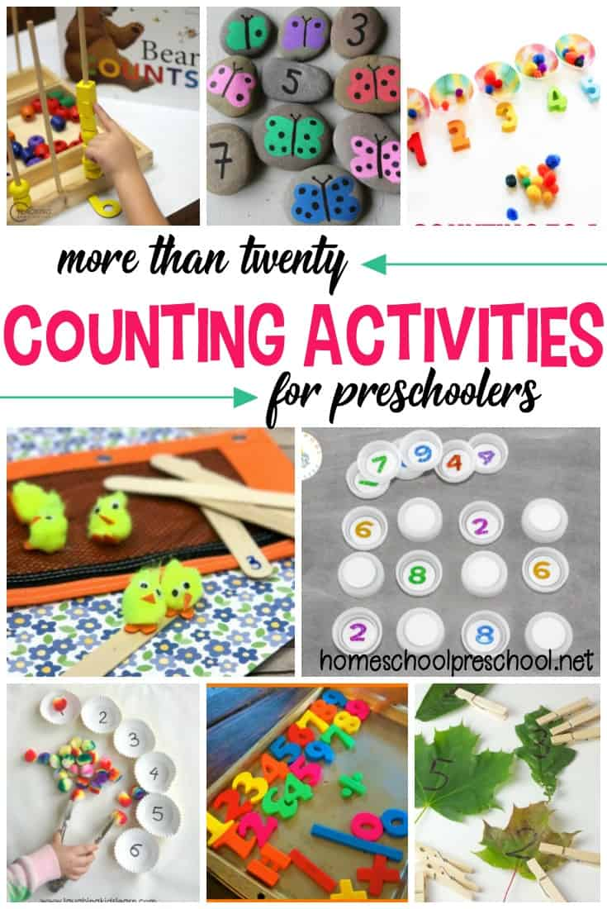

Challenges
Week 2

Create a collage of a garden using scrap materials from magazines.

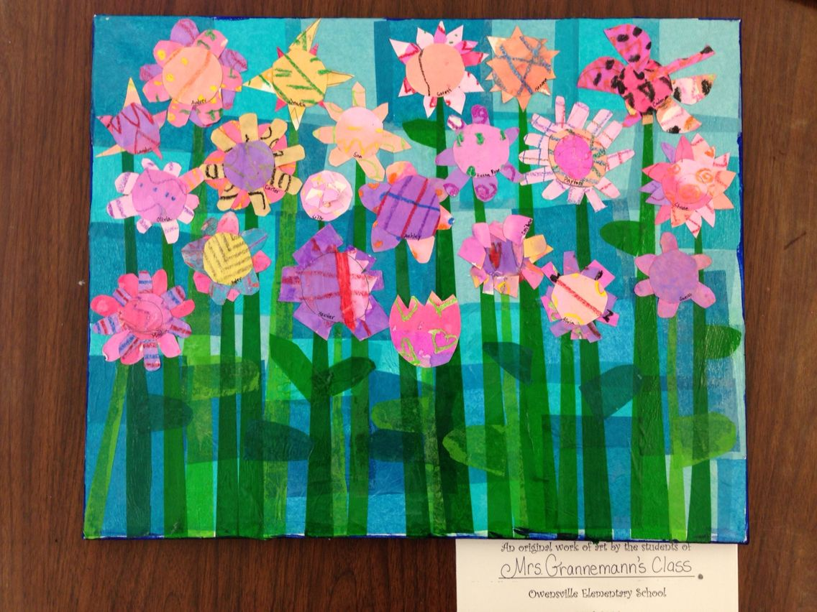

Challenge 2
Make an Easter card. Have a look online and make a card.


