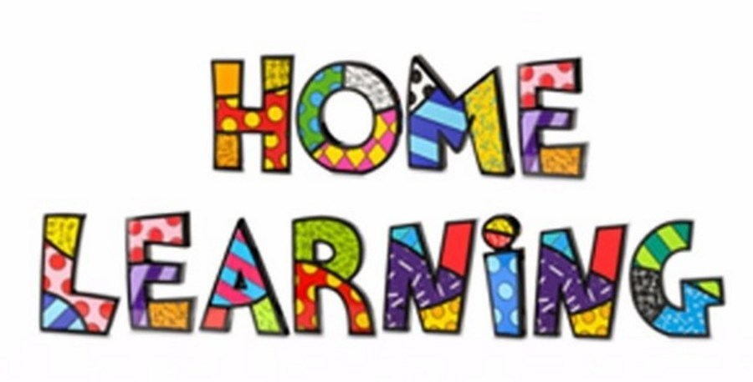

Week 5 – 27.4.2020
Literacy:- Letter W. This week pupils are to work on the letter W.
Letter W song - https://www.youtube.com/watch?v=VYhY_MS2cbc
Mr Tumble Alphabet song https://www.youtube.com/watch?v=mMog84sQp3o

Which pictures begin with the letter W?
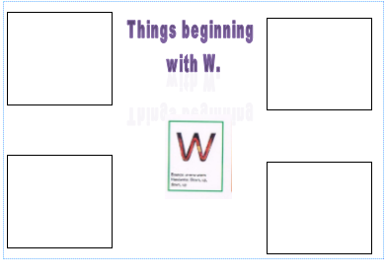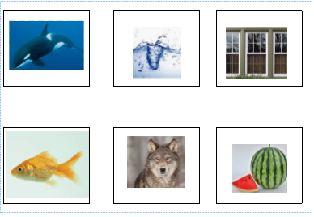
Match the pictures to the letter sound.
Practice writing the letter in different multisensory ways
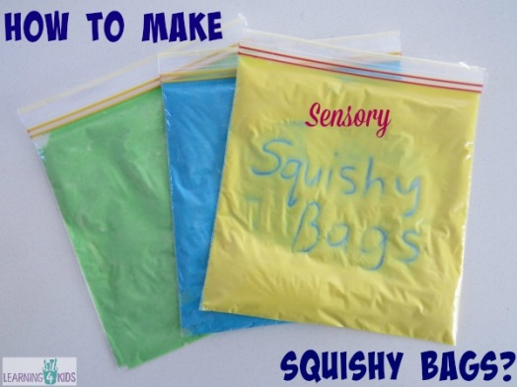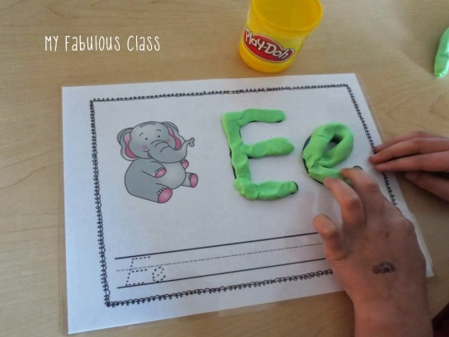

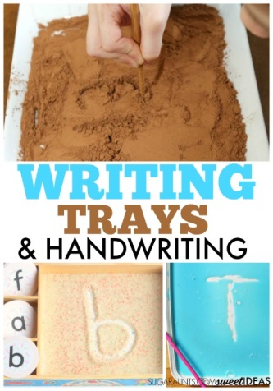

Writing your name
Practice writing your name in a range of multisensory ways.
Reading
Read ‘Peace at last’. You can find the story on YouTube.
https://www.youtube.com/watch?v=9U9y35kWBvM
Using the colourful semantic card, discuss who is in the story. Can the pupils name the characters in the story? Pupils to point to the characters on request and repeat their names. Draw and make special marks to represent the characters.

Maths:- Find 3D shapes around the house and say what they are. Sort the 3D shapes under their headings.
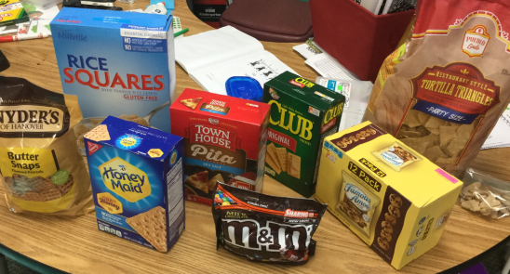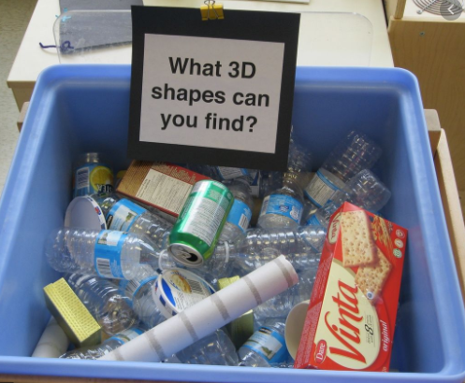

Make a tower using the 3D packaging, count how many you use. Make different models, a castle, a tower, a ship or a rocket and take photographs.
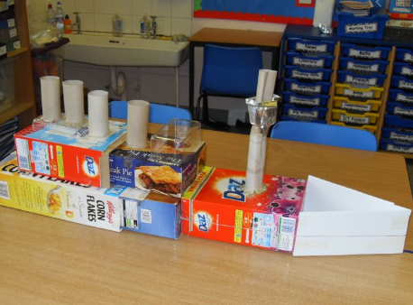

Maths:- Number recognition. To recognise numbers 0-10. Number songs. Counting objects. Practice forming the numbers. How many flowers can you find in the garden?
Number songs - https://www.youtube.com/watch?v=dk9Yt1PqQiw
https://www.youtube.com/watch?v=5dqGDSOMHRo
Ideas:- Practice forming the numbers and numbers in a range of multi sensory approaches.
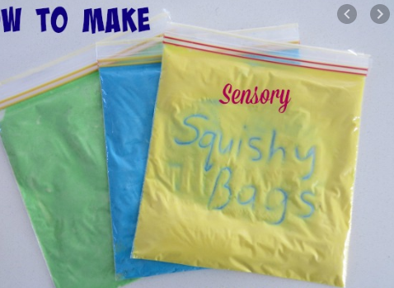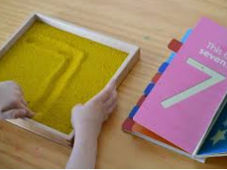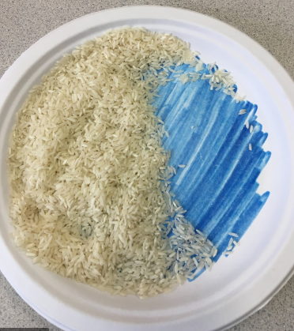

Challenges
Week 5
Challenge 1
Look out the window during the day and what can you see. Create a daytime picture using different materials. Think about what you can see during the daytime.
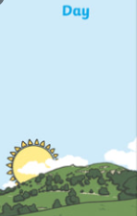
Challenge 2
Make a bear puppet to retell the story Peace at Last.
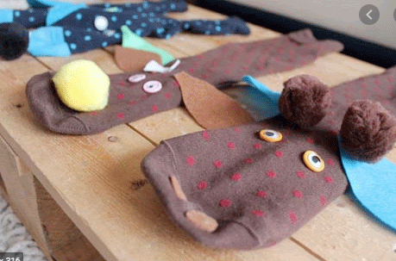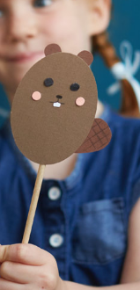

P.E. Challenge:
Join in with Joe Wicks PE 30 min a day via YouTube live every morning at 9am (Mon-Fri). Or go on a 30 min walk everyday but stay safe.

Numeracy Challenges
Play games on the following websites, particularly working in number skills such as place value, addition and subtraction
www.topmarks.co.uk
Go outside, draw your numbers using chalks, and count the correct amount of objects.
Make a big number 1 using outdoor materials.

