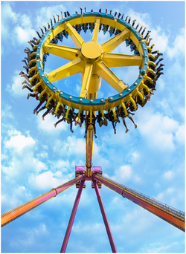
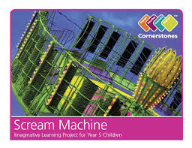
Scream Machine Homework
Over the next term Year 4 & 5 will be learning about theme parks and roller coasters. In the grid below you will find many interesting activities for you to complete at home. Choose one activity each week to complete in your homework book. Your book will need to be returned to school every Wednesday for the class reflection time where homework will be displayed and shared with class peers.
Numeracy / Literacy  Plan a trip to a local theme park for your family. Calculate how much it will cost, how long it will take to get there and write an itinerary for the day. | History / ICT/ DCF  Research the history of fairground rides, and create a PowerPoint presentation that includes information, timelines, pictures, film and sound clips. | Design Technology  Make a fairground ride/rollercoaster using available materials (Lego, Kinex, etc). Why not include a loop the loop? | Literacy  Write a diary entry after a trip to the fair (real or imaginary!) How did you feel? What did you see/hear/smell?
History/ ICT/DCF/ Geography  Research and write a biographical account of Walter Elias Disney, animator and entrepreneur. Find the location of Disney theme parks around the world. | History/ ICT/DCF/ Geography  Research online to find information about roller coasters from around the world. Which is the oldest? The longest? The scariest? Record your results in a table. | Numeracy  Use the web to investigate mathematical data about a range of different theme park rides. Find information such as the ride’s length, g-force, type and height | Design Technology  Explore your home and the surrounding area to look for machines, toys and other objects that use cams, gears, levers and pulleys. Take photos and create a montage of all the different mechanisms found
Art  Sketch/create your face as if you were on a rollercoaster. Be as imaginative and creative as you can! | Design Technology  Have a go at making fairground foods!  Why not put your own twist on it? | Science  Research one scientific force e.g gravity, air resistance, friction and create an information poster about it. | Literacy  Write an acrostic poem about a roller coaster. Describe the sights, sounds, forces, movements, smells and tastes of being at a theme park or on a roller coaster!

