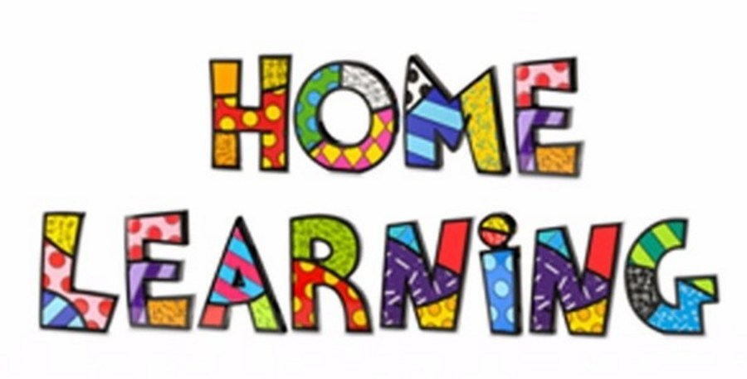

Week 3 & Easter Holidays
Literacy:- Letter Y. This week pupils are to work on the letter Y.
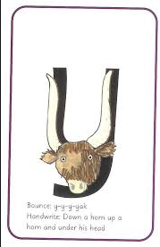
Letter Y song. https://www.youtube.com/watch?v=Slu-XafZ6Ww
Mr Tumble Alphabet song https://www.youtube.com/watch?v=mMog84sQp3o
Which pictures begin with the letter Y.?
Match the pictures to the letter sound.
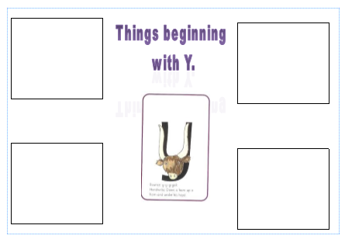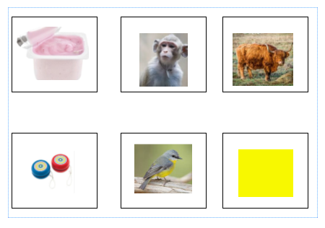
Practice writing the letter in different multisensory ways
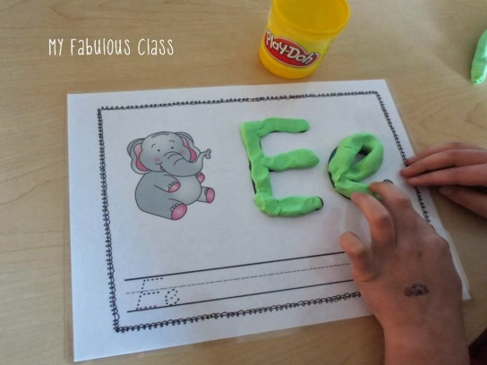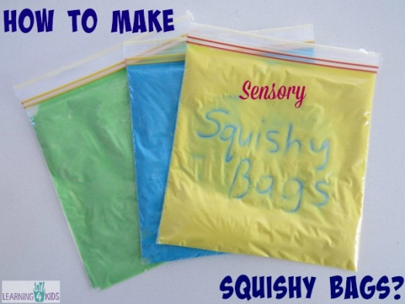

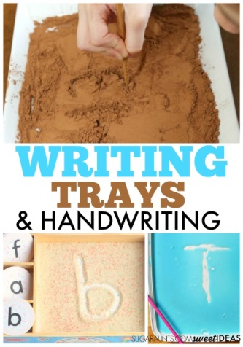

Writing your name
Practice writing your name in a range of multisensory ways.
Reading
Read a range of stories, you can find many online or just read the books you have at home with your parents and use the ‘Who’ card to recall ‘Who’ is in the story.

Maths:- Sorting objects by colour or criteria. Find many objects of different colours around the house. Pupils to sort the objects by colour.
Ideas:- Get a number of bowls or plates and sort objects by colour.

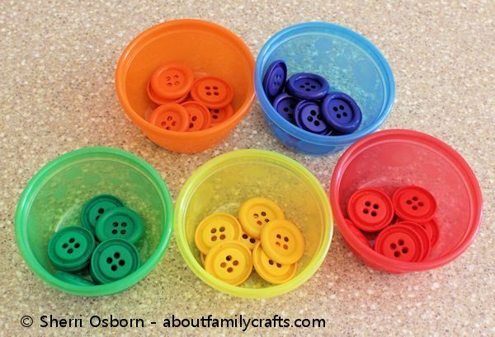
Maths:- Number recognition. To recognise numbers 0-10. Number songs. Counting objects around the house.
Number songs - https://www.youtube.com/watch?v=dk9Yt1PqQiw
Number blocks on the internet are also a good resource.

Measuring around your foot (like we did with the giant’s foot)
Draw around your foot and use non-standard units to measure.

Go into the garden and look around the house to find things that are longer and shorter than your foot. Sort the objects into longer and shorter and take a photograph. How many things can you find that are longer and shorter than your foot?
Mathematical language to be use – Longer and shorter

Easter Holiday Challenges
Design an Easter Egg – IT
It would normally be the Easter holidays. I would like you to design your own Easter egg using
Login to your HWB account (user name and password was sent home in file) and draw an egg. Think of the shape and colours.

First log in to Hwb and then select

Next choose

Finally choose the
this is where you can draw your egg.
Please remember to save your work and name it.
Or
Simple paint a design on a hard boil egg. You can have an egg rolling competition.

Creative work
Get creative and make your own Easter bunny or chick. Below are just a few examples but you can create your own.



