

Week 6 – 04.5.2020
Literacy: - Letter Z. This week pupils are to work on the letter Z.
Letter Z song - https://www.youtube.com/watch?v=1rjrrJ9Dgk8
Mr Tumble Alphabet song https://www.youtube.com/watch?v=mMog84sQp3o
Read Write Inc. have now announced that their resources are free. Click on the linked below.
https://m.youtube.com/channel/UCo7fbLgY2oA_cFCIg9GdxtQ
This link allows you to download resources. Scroll down to the letter, which we are learning. https://home.oxfordowl.co.uk/reading/reading-schemes-oxford-levels/read-write-inc-phonics-guide/

Which pictures begin with the letter z?
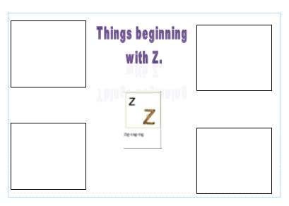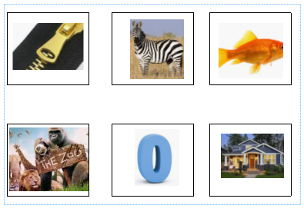
Match the pictures to the letter sound.
Practice writing the letter in different multisensory ways
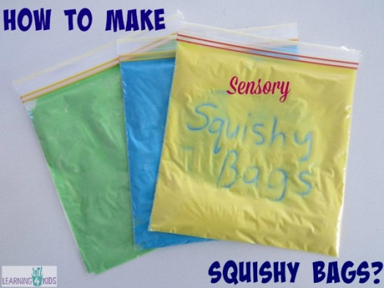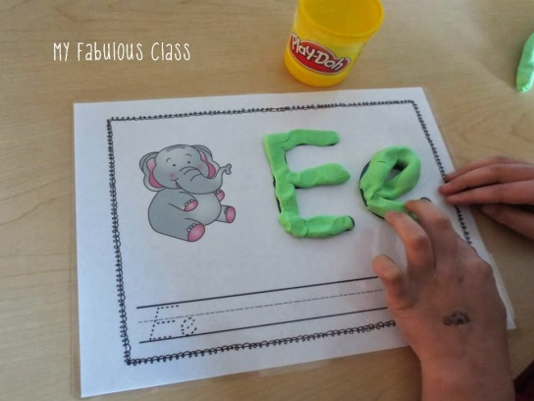

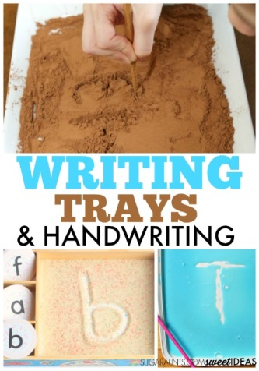

Writing your name
Practice writing your name in a range of multisensory ways.
Pencil control
Continue to practice your pencil control. Templates are on the webpage.
Reading
Continue to read ‘Peace at last’. You can find the story on YouTube.
https://youtu.be/9U9y35kWBvM
Task 1
Using the colourful semantic card, discuss who is in the story. Pupils will need to name the characters. Discuss what the character are doing. For example, Mrs Bear snoring.
Task 2
Make special marks and draw a picture of Mr Bear. Overwrite the words daddy bear underneath the drawing.

Task 3 -Teddy puzzle – on the webpage
- Colour in the teddy bear and add eyes, a nose and mouth.
- Cut out each part of the jigsaw carefully, following the lines.
- Mix up the pieces and put them together again

Maths: - Pattern
Create a pattern using the bears. You can use two colours or more. I have attached worksheets onto the webpage. You can use objects found in the house. Use the garden, for example, a daisy and a leaf. Take photographs of your patterns and post them on DoJo.
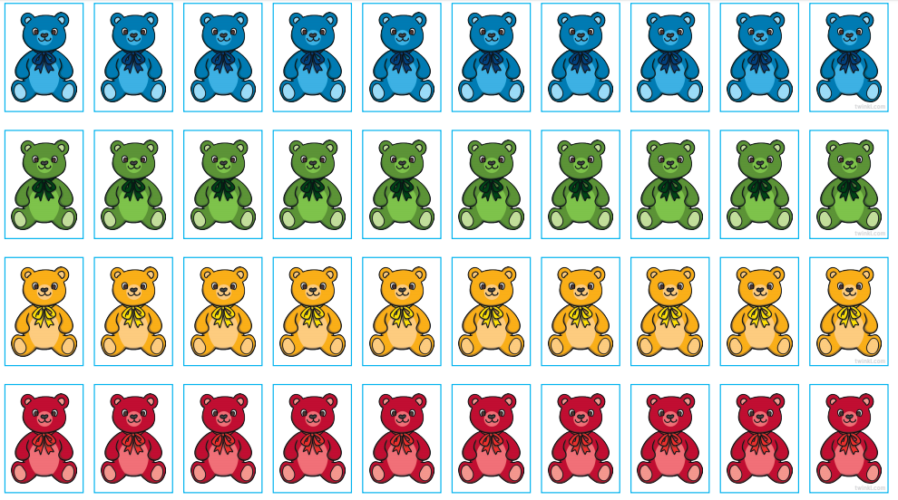

Maths: - Number recognition. To recognise numbers 0-10. Number songs. Counting objects. Practice forming the numbers. How many birds can you find in the garden?
Number songs - https://www.youtube.com/watch?v=dk9Yt1PqQiw
https://www.youtube.com/watch?v=5dqGDSOMHRo
Ideas: - Practice forming the numbers and numbers in a range of multi-sensory approaches.
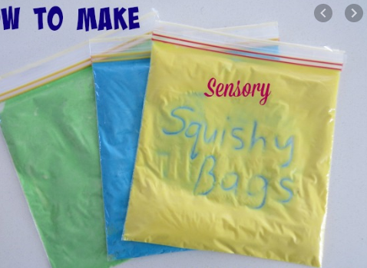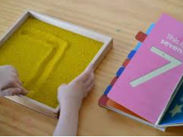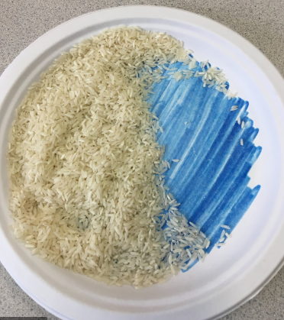

Can we focus on the formation of number 1 this week. I have attached some worksheets to help. However, you can form the number in sand, rice, paint, chalk or any other materials. You could even use your child’s favourite cereal.

VE Day on Friday 8th May
Look at the PowerPoints and look at the pictures.
Design and make a medal for a war hero. You can draw it or make it out of playdough. It can be any shape or size.
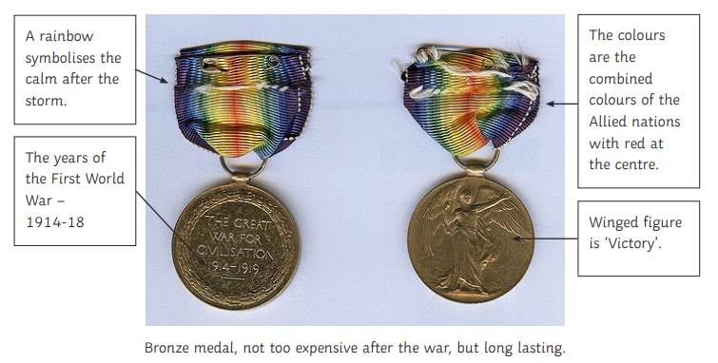

Colour in and make your flag of the United Kingdom to wave around on VE Day.


Challenges
Week 6
Challenge 1
Look out the window during the night and talk about what you can see. Create a night-time picture using different materials.

Challenge 2 – Light sources


Go around your home and find different sources of light. Take photographs of the light sources. Send pictures on Dojo of the different light sources.

Challenge 3
Make a moveable bear. You can draw your own or use the template on the page.
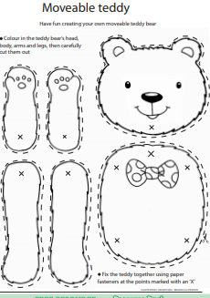

P.E. Challenge:
Join in with Joe Wicks PE 30 min a day via YouTube live every morning at 9am (Mon-Fri). Alternatively, go on a 30 min walk everyday but stay safe.

Numeracy Challenges
Play games on the following websites, particularly working in number skills such as place value, addition and subtraction
www.topmarks.co.uk
Go outside, draw your numbers using chalks, and count the correct amount of objects.
Make a big number 1 using outdoor materials.

