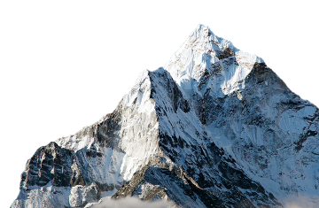
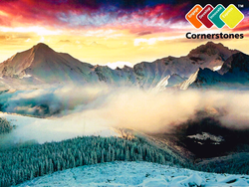
Misty Mountain Sierra Homework
Over the next term Year 4 & 5 will be learning about mountains and mountain ranges across the world . In the grid below you will find many interesting activities for you to complete at home. Choose one activity each week to complete in your homework book. Your book will need to be returned to school every Friday for the class reflection time where homework will be displayed and shared with class peers.
Numeracy / ICT/DCF  Research the 5 highest mountains in the world. Use this information to create a graph of your choice in Microsoft Excel. Make sure you include correct axis on your graph. | Numeracy / Geography / ICT/ DCF  Choose one of the world’s highest mountains and create a PowerPoint presentation all about it to show your class. Don’t forget to include lots of interesting images and information! | Literacy  Create fact files about famous mountaineers such as George Mallory, Sir Edmund Hilary and Reinhold Messner | Literacy  Write an information book explaining how different types of mountains are formed. Include labelled diagrams showing each type. You could look at fold, block, dome, volcanic or plateau mountains and give examples of each mountain type.
Literacy  Write a diary entry for a child living in a mountainous region of the world. What happens in their daily life? How would their day differ from your own? | History/ ICT/DCF  We’ve talked about the Yeti… Now research other mysterious primates that have inspired people to search for them, such as Bigfoot, in the USA or the Yeren of China. Make ‘Wanted’ posters featuring an illustration of what you think they may look like. | Numeracy/Geography  What is the highest mountain in Wales? In what county is it located?  Create a map of the highest mountains in Wales. Make sure you include a key for your map. | Expressive Arts /Design Technology  Research mountain sports such as skiing, snowboarding, rock climbing or mountain biking. Choose one that excites you, and create a scrapbook of information and images. Feature the equipment or clothing needed and the world’s best competitors in the sport. Perhaps you could join a class or club and try the sport out for yourself?
Expressive Arts  Write a ‘water cycle’ song or rap. Make sure you include key words, such as condensation, precipitation and evaporation. | Design Technology  Create a 3-D food model of a mountain, mountain range or a particular local hill, using ingredients of your choice. You could use jelly, cake, or even mashed potato! Who can make the highest structure? Or the most realistic one? Take a picture to compare with your classmates’ models. | Science  Find out about animals that inhabit a mountainous area of the world. How do they adapt and survive? Are any of these animals endangered? Why? | Literacy  Write a ‘true or false?’ quiz which includes amazing statements about mountains of the world.

