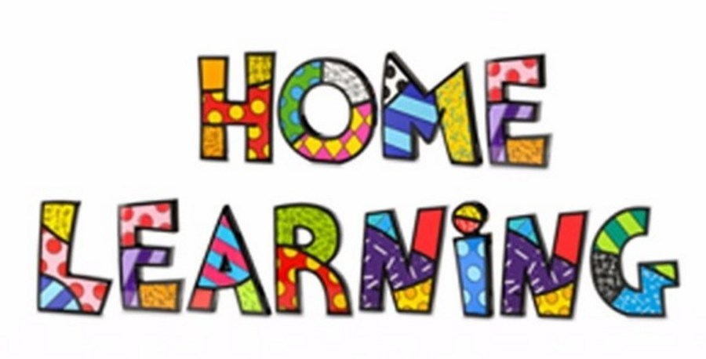

Week 10 – 08.6.2020
Task 1
Literacy: - Letter s. This week pupils are to work on the letter, s. Practice the letter formation and sound with your child daily. Sings songs daily.
Letter s song - https://www.youtube.com/watch?v=brdnfX6FIh0
Mr Tumble Alphabet song https://www.youtube.com/watch?v=mMog84sQp3o
Read Write Inc. have now announced that their resources are free. Click on the linked below.
https://m.youtube.com/channel/UCo7fbLgY2oA_cFCIg9GdxtQ
This link allows you to download resources. Scroll down to the letter, which we are learning. https://home.oxfordowl.co.uk/reading/reading-schemes-oxford-levels/read-write-inc-phonics-guide/
Use the link below to practice the RWI sounds in the daily sound book.
https://www.oxfordowl.co.uk/api/interactives/29318.html
Complete the worksheets attached to the website.
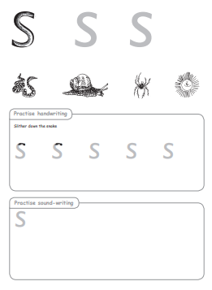

Practice writing the letter in different multisensory ways
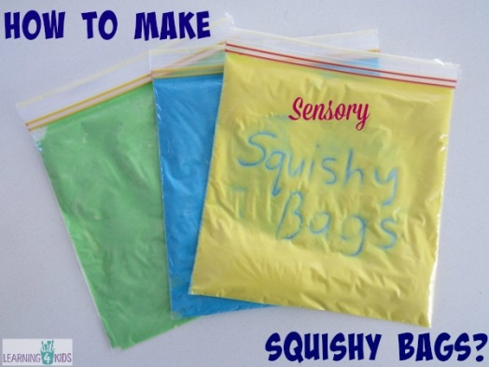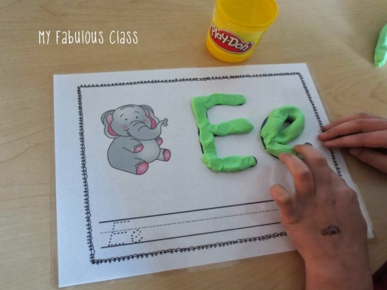

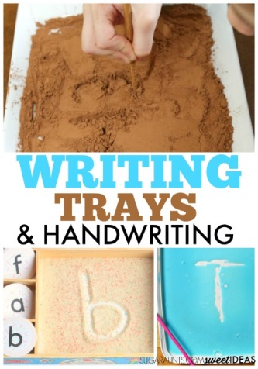
Task 2
Writing your name
Practice writing your name in a range of multisensory ways.
Task 3
Pencil control
Continue to practice your pencil control. Templates are on the webpage.

Maths: - Number recognition. To recognise numbers 0-10. Number songs. Counting objects. Practice forming the numbers. How many flowers or stones can you find in the garden? Count out the correct amount of objects.
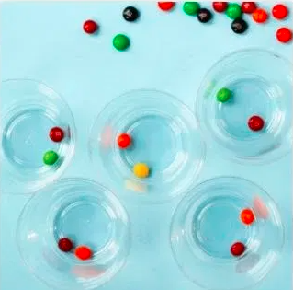
Number songs - https://www.youtube.com/watch?v=dk9Yt1PqQiw
https://www.youtube.com/watch?v=5dqGDSOMHRo
Ideas: - Practice forming the numbers and numbers in a range of multi-sensory approaches.
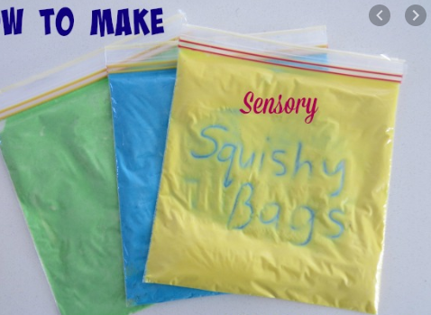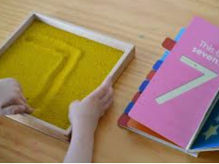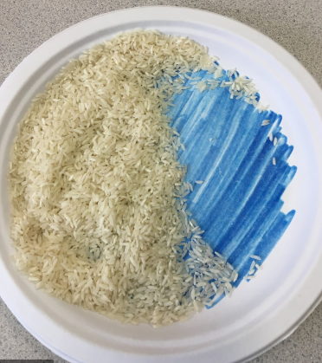

Can we focus on the formation of number 5 this week. I have attached some worksheets to help. However, you can form the number in sand, rice, paint, chalk or any other materials. You could even use your child’s favourite cereal.

Challenges
Week 10

Thinking Challenges
Our new topic for this half term is the Seaside. What do you know about the seaside. Cut and stick pictures around the image of the seaside of everything you can name and think of. Find your own pictures.
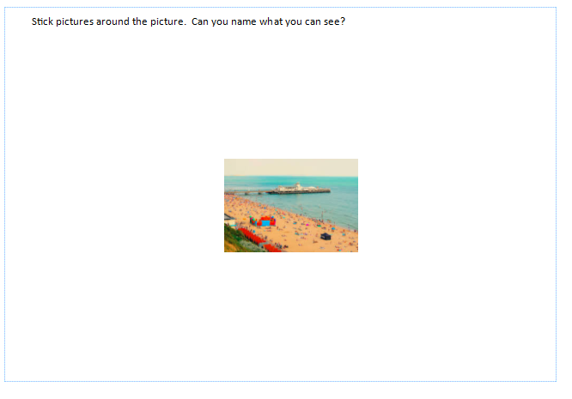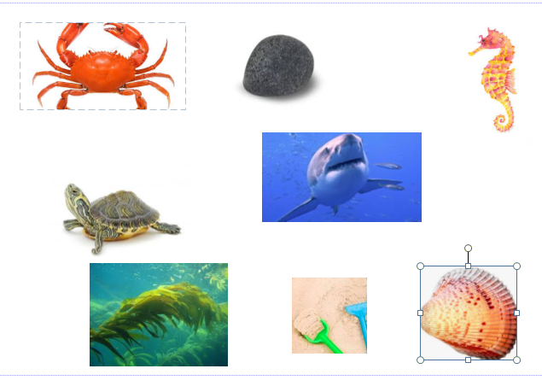

Creative Challenge
Create a seaside scene using different mediums. You can use a range of materials including sand, shiny paper.
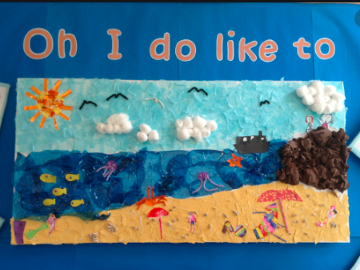
Memory games
Play ‘Kim’s game’. Put a few items on a tray (for example, a crayon, an apple, a building brick, a toy car). Then look, cover, remember and check!

Health and Well being challenge
Join in with Joe Wicks PE 30 min a day via YouTube live every morning at 9am (Mon-Fri). Alternatively, go on a 30 min walk everyday but stay safe.

Numeracy Challenges
Play games on the following websites, particularly working in number skills such as place value, addition and subtraction
www.topmarks.co.uk
Go outside, draw your numbers using chalks, and count the correct amount of objects.
Make a big number 5 using outdoor materials.
Match the numbers to the dots. This can be done on paper really easily.


