  6 |  |  |  | Theme: Misty Mountain Sierra  Year group: Year 4/5
Literacy     | Numeracy     | Creative     | Thinking     |  | Healthy me    
Using the internet and other resources available to you, create a biography based on Sir Edmund Hillary.  Your biography must contain the following:  - Title  - Introductory paragraph  - Early life  - His middle life/major achievements  - Retirement and later life. | Pole to Pole: In this activity you will find out about the very top and bottom of the planet.  Using the data provided create graphs which display the number of daylight hours in London and the Arctic Circle.  Using these graphs consider the impact of daylight hours in each location. | Using card, cardboard, paper and other resources create a model of a mountain environment which displays contours.  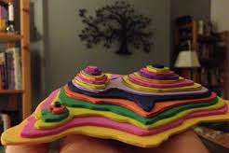 | Wales is blessed with many different mountains.  Create a map of Wales which includes major towns, cities, mountains and rivers. Remember to include a key to help the readers understand the map. |  | 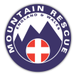  Use the internet to research the Mountain Rescue.  Find out the following:  - Who they are?  - What they do?  - Equipment used?  - Additional information

