  1 |  |  |  | Theme: Misty Mountain Sierra  Year group: Year 4/5
Literacy     | Numeracy     | Creative     | Thinking     |  | Healthy me    
Using your knowledge and other sources of information, create a double page fact file based on a mountain of your choice.  Your fact file should include the following:  - A title  - An introduction to the mountain  - Divided into paragraphs with subheadings  - Factual information  - Topic vocabulary  - Pictures and diagrams  - Bright and colourful | Which mountain would you like to climb?  Conduct a survey of friends and adults to investigate which mountains they would like to climb.  Digital element  Once you have collected the data use Hwb > Microsoft Excel to display your findings.  Which mountain was the most popular to climb? | Using a range of material to plan, design and create a 3D model mountain.  Once your model has dried, use paints to decorate and add detail  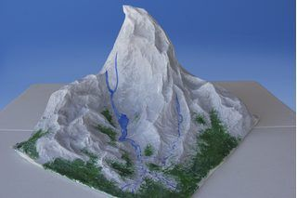 | Animal adaptation  Watch the following video clip  https://www.bbc.co.uk/bitesize/clips/zbp6n39  Using the information provided and your own knowledge, to create a knowledge organiser based on how the Snow Leopard has adapted to the mountain environment. |  | Sherpas – life in the mountains.  Read and note information based on Sherpas’  - Culture  - Life  - Language  - Religion  - Traditional dress, diet and homes.  

