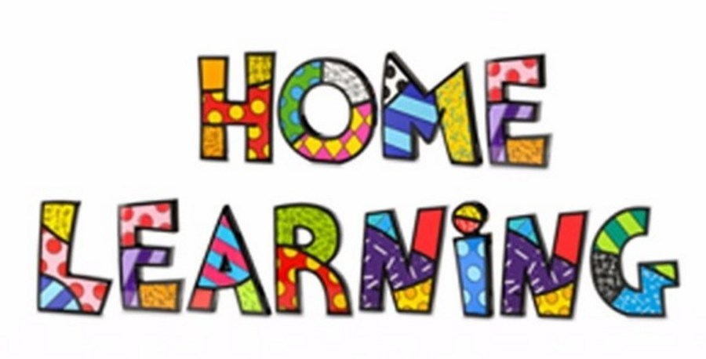

Week 7 – 11.5.2020
Literacy: - Letter X. This week pupils are to work on the letter, X.
Letter X song - https://www.youtube.com/watch?v=YlznBn_8S9w
Mr Tumble Alphabet song https://www.youtube.com/watch?v=mMog84sQp3o
Read Write Inc. have now announced that their resources are free. Click on the linked below.
https://m.youtube.com/channel/UCo7fbLgY2oA_cFCIg9GdxtQ
This link allows you to download resources. Scroll down to the letter, which we are learning. https://home.oxfordowl.co.uk/reading/reading-schemes-oxford-levels/read-write-inc-phonics-guide/
Use the link below to practice the RWI sounds in the daily sound book.
https://www.oxfordowl.co.uk/api/interactives/29318.html
Complete the worksheets attached to the website.
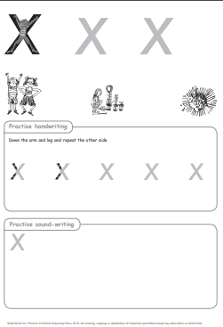

Practice writing the letter in different multisensory ways
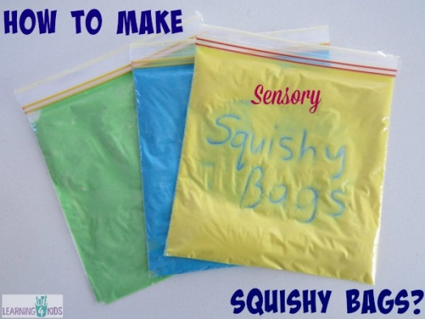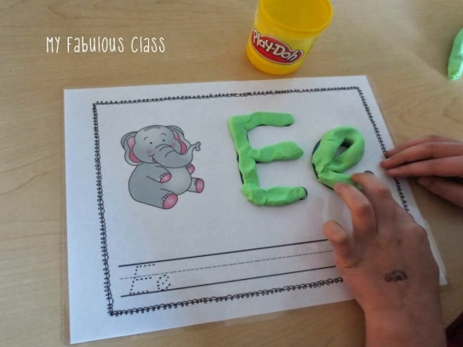

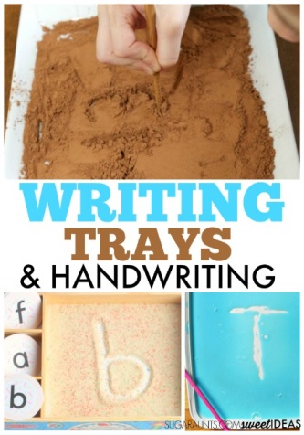

Writing your name
Practice writing your name in a range of multisensory ways.
Pencil control
Continue to practice your pencil control. Templates are on the webpage.
Reading
Continue to read ‘Peace at last’. You can find the story on YouTube.
https://youtu.be/9U9y35kWBvM
Task 1
Use the puppets to act out parts of the story in order. For example, Mrs Bear snoring. Puppets attached to webpage.
Task 2
Make special marks and draw a picture of Mrs Bear. Overwrite the words Mrs Bear underneath the drawing.

Maths: - Measurement
Order the bears in size. Largests to smallest. You can use real teddy bears or use the worksheet attached.
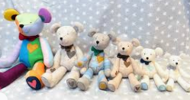
Make your own bears out of craft materials, showing the different sizes.
Maths: - Number recognition. To recognise numbers 0-10. Number songs. Counting objects. Practice forming the numbers. How many birds can you find in the garden?
Number songs - https://www.youtube.com/watch?v=dk9Yt1PqQiw
https://www.youtube.com/watch?v=5dqGDSOMHRo
Ideas: - Practice forming the numbers and numbers in a range of multi-sensory approaches.
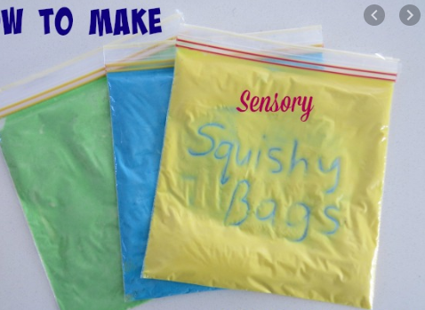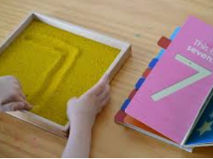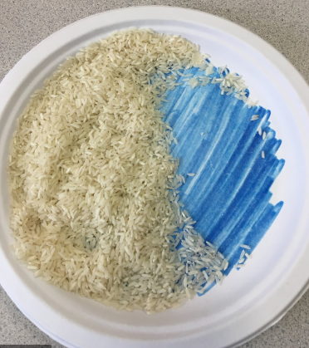

Can we focus on the formation of number 2 this week. I have attached some worksheets to help. However, you can form the number in sand, rice, paint, chalk or any other materials. You could even use your child’s favourite cereal.

Challenges
Week 7
Challenge 1
Watch the PowerPoint attached to the webpage. Think about when we wear our pyjamas, or when we eat breakfast. Sort the pictures into the night and day.

Challenge 2 – Light sources


Look at the PowerPoint, sources of light.
Using the pictures, sort the pictures into sources of light and not sources of light.

Challenge 3
Make teddy bear toast using fruit.
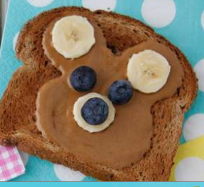
Name and sign the ingredients you are using.
Challenge 4
The moon is shown in a number of the illustrations. Use a book about space or the internet to find out about the moon and create your own image of the moon

P.E. Challenge:
Join in with Joe Wicks PE 30 min a day via YouTube live every morning at 9am (Mon-Fri). Alternatively, go on a 30 min walk everyday but stay safe.

Numeracy Challenges
Play games on the following websites, particularly working in number skills such as place value, addition and subtraction
www.topmarks.co.uk
Go outside, draw your numbers using chalks, and count the correct amount of objects.
Make a big number 2 using outdoor materials.

