Blended Learning – Year 4 and 5
Topic: Welsh (Ms Davies)

Missions:
Complete the 3 Welsh missions:
- Write a first person profile on one of the Characters in the Stori Nadolig (Nativity Story). Use the Welsh names for your chosen character and use the relevant language patterns. When writing your profile try to think about how the character must be feeling.
Mair – Mary
Joseff – Joseph
Gabriel – Gabriel
Bugail – Shepherd
Brenin – King
Buwch – Cow
Dafad – Sheep
Iesu – Jesus
Anrhegion – Presents

- Research the Welsh artist Helen Elliott. Write a short biography about her and write a sentence about each of the 3 paintings. Create your own Christmas themed picture using Helen Elliott’s work as an example.
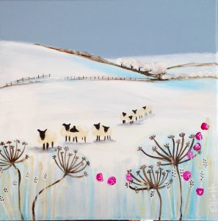
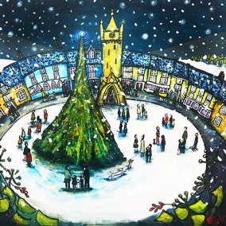
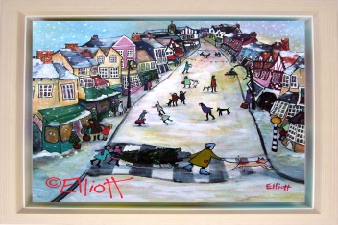

- Write out the translation of the Silen Night (Dawel Nos) in the center of the page and then draw some Nativity themed illustrations around the words. You can use the English version of the song to help with your drawings. Find the meaning of some of the Welsh words by comparing it to the English version of the song.
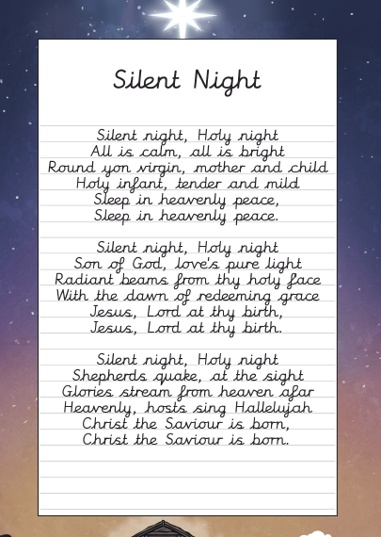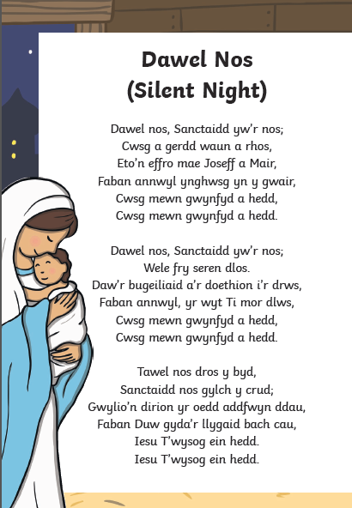

Directed Task:
Write a letter from one of the characters to another in the Nativity Story.
Use your language patterns to write the letter.
Think carefully about how the characters might be feeling at the time. Remember that when writing a letter you need to pretend that you are that character and are therefore writing in the first person. Examples of the patterns you may wish to use are:
Sut wyt ti?
Dw i'n hapus/trist/ofn
Dw i'n hoffi / ddim yn hoffi
Sut mae’r tywydd? Mae hi’n oer/heulog/gymylog
Dw i eisiau ….
Yn fy marn i ..
Sut wyt ti’n teimlo?

Remember a letter must have all of the following:
- Address of the sender (top right hand side of the page) you can make this up
- Greeting – Annwyl (dear)…..
- Beginning, Middle and End
- Finish with Oddi wrth ….

