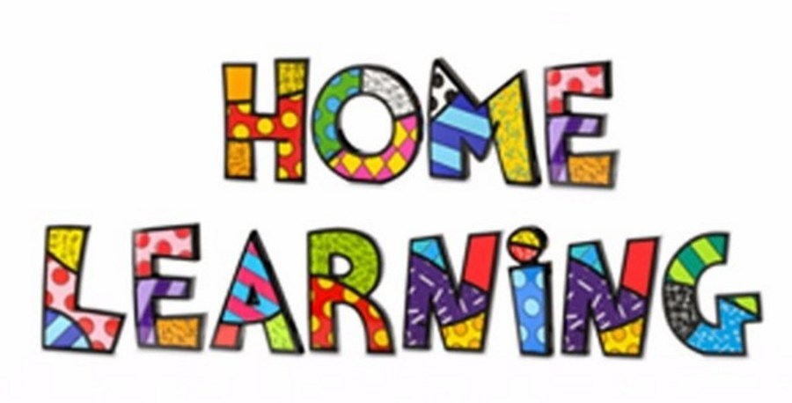

Week 9 – 01.6.2020
Task 1
Literacy: - Letter a. This week pupils are to work on the letter, a.
Letter a song -https://www.youtube.com/watch?v=VKCV8nnIfLo
Mr Tumble Alphabet song https://www.youtube.com/watch?v=mMog84sQp3o
Read Write Inc. have now announced that their resources are free. Click on the linked below.
https://m.youtube.com/channel/UCo7fbLgY2oA_cFCIg9GdxtQ
This link allows you to download resources. Scroll down to the letter, which we are learning. https://home.oxfordowl.co.uk/reading/reading-schemes-oxford-levels/read-write-inc-phonics-guide/
Use the link below to practice the RWI sounds in the daily sound book.
https://www.oxfordowl.co.uk/api/interactives/29318.html
Complete the worksheets attached to the website.
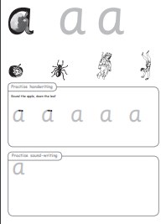

Practice writing the letter in different multisensory ways
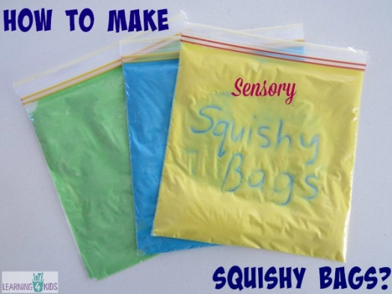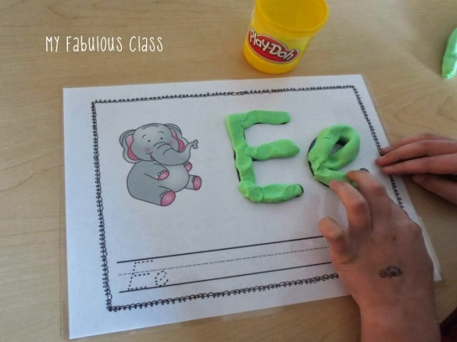

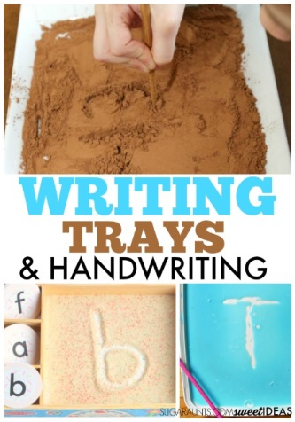
Task 2
Writing your name
Practice writing your name in a range of multisensory ways.
Task 3
Pencil control
Continue to practice your pencil control. Templates are on the webpage.
Task 4
Reading
Listen to the story ‘Owl Babies’’. You can find the story on the link below
https://vimeo.com/55971653

Go through the key parts of the story. Recap on the character’s names in the book.
Using the colourful semantic cards, discuss what Bill can see. Use the cards and say Bill can see ….
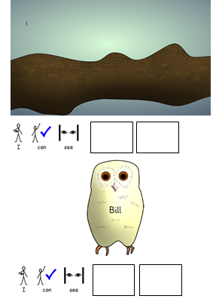

Sequence the story
Show the pupils two pictures from the story and ask them which one comes First. Place them on the correct part of the board.
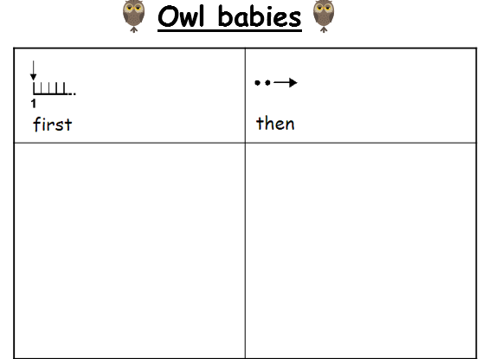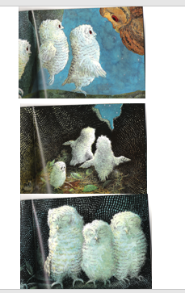

Maths: - Measurement
Capacity Full and empty.
Watch the video about full and empty
https://www.youtube.com/watch?v=TJKwtpm6MaY
Have fun playing with water. Use different containers fill them up until they are full. Have empty containers, pupils to sort the full and empty containers. Use different objects to fill the containers. Count how many you need to fill the containers. You can also practise with other objects, a full and empty box.

Sing these songs linked to capacity.
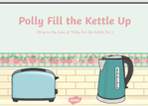

Maths: - Number recognition. To recognise numbers 0-10. Number songs. Counting objects. Practice forming the numbers. How many flowers or stones can you find in the garden?
Number songs - https://www.youtube.com/watch?v=dk9Yt1PqQiw
https://www.youtube.com/watch?v=5dqGDSOMHRo
Ideas: - Practice forming the numbers and numbers in a range of multi-sensory approaches.
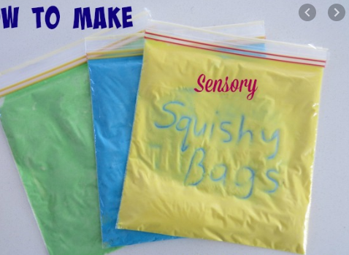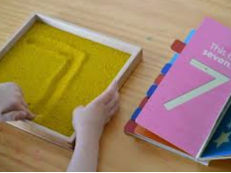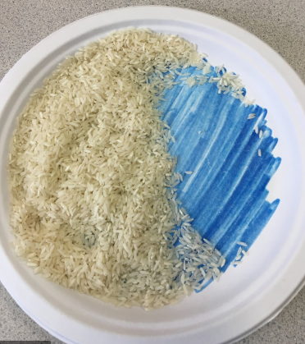

Can we focus on the formation of number 4 this week. I have attached some worksheets to help. However, you can form the number in sand, rice, paint, chalk or any other materials. You could even use your child’s favourite cereal.

Challenges
Week 9
Challenge 1
Environmental art. Go outside and use materials in the garden to make your own owls. Send me pictures on Dojo.
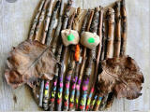

Challenge 2 – Owl toast
Have fun making owl toast. Listen to your parents and follow the instructions.
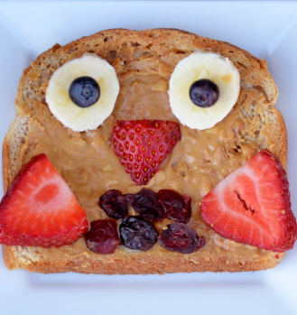

Challenge 3
Day and night animals
Watch the PowerPoint and sort the animals into day and night. Ask the children to find the bat and place it on the picture with the moon etc.
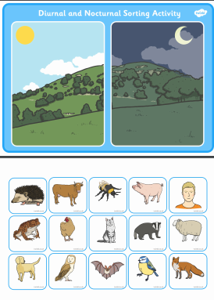
Challenge 4
Memory games
Play ‘Kim’s game’. Put a few items on a tray (for example, a crayon, an apple, a building brick, a toy car). Then look, cover, remember and check!

Challenge 5
P.E. Challenge:
Join in with Joe Wicks PE 30 min a day via YouTube live every morning at 9am (Mon-Fri). Alternatively, go on a 30 min walk everyday but stay safe.

Numeracy Challenges
Play games on the following websites, particularly working in number skills such as place value, addition and subtraction
www.topmarks.co.uk
Go outside, draw your numbers using chalks, and count the correct amount of objects.
Make a big number 4 using outdoor materials.

