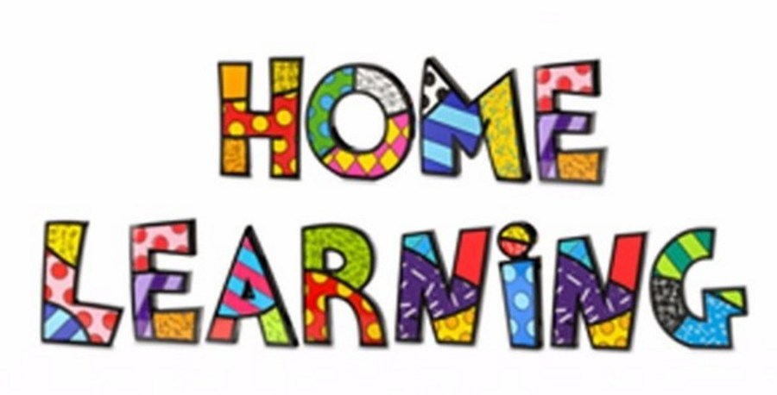
Week 2
Literacy:- Create an Acrostic poem using the word ‘flower’. Example of an Acrostic poem below.
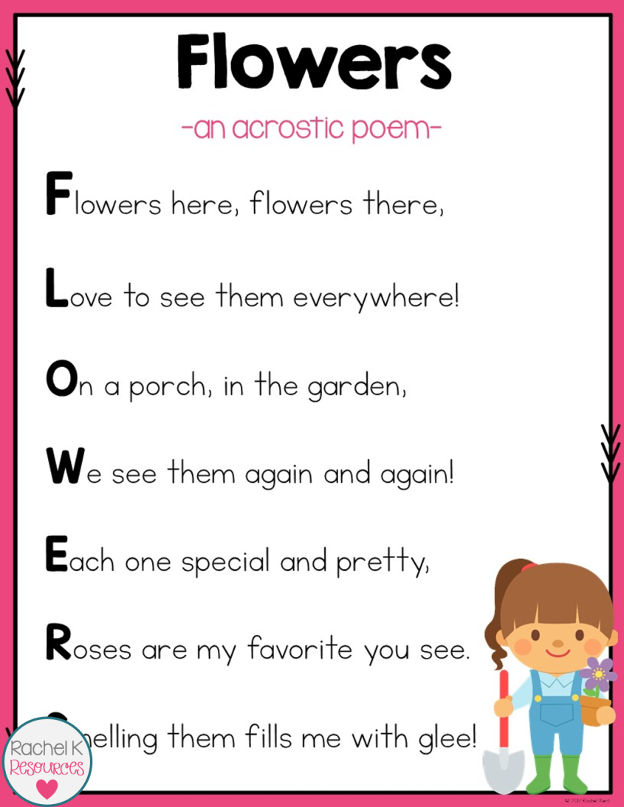
Easter Story
Read the Easter Story found on http://www.communication4all.co.uk/http/Easter.htm. Use the colourful semantic cards ‘Who’, ‘what doing’, ‘what’, ‘where’. Talk about the picture using the cards and write sentences for each picture.

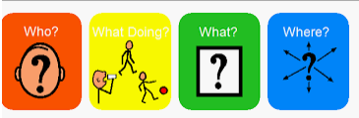

Maths:- Look at missing numbers in a sum ( see below). Practise the 2 x, 5x, 10x tables. If you are ready move onto your 3x tables.
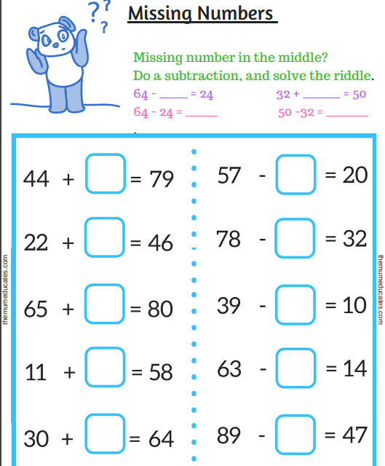
Play addition and subtraction game on topmarks. https://www.topmarks.co.uk/maths-games/5-7-years/addition-and-subtraction.
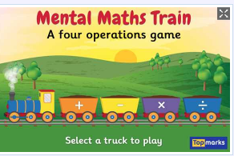
Challenges
Week 2
Create a collage of a garden using scrap materials from magazines.

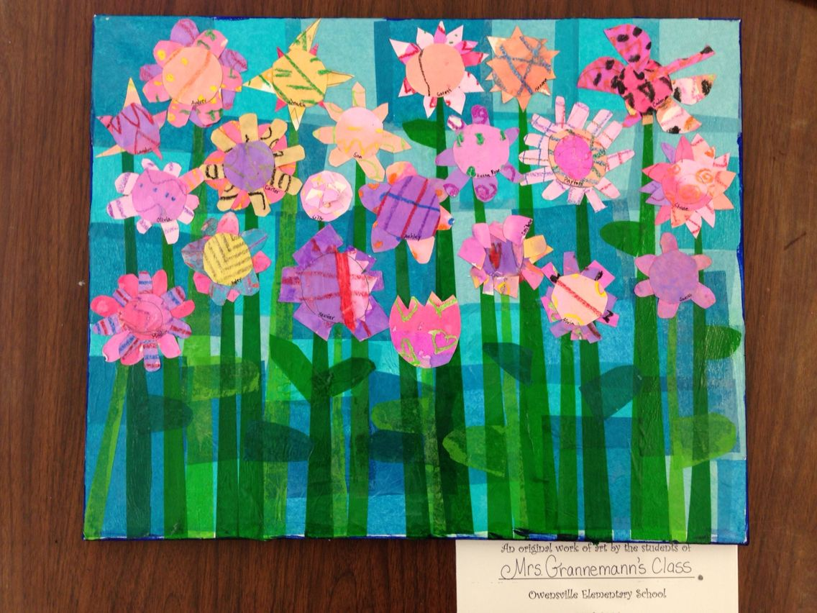

Challenge 2
Make an Easter card. Have a look online and make a card.


