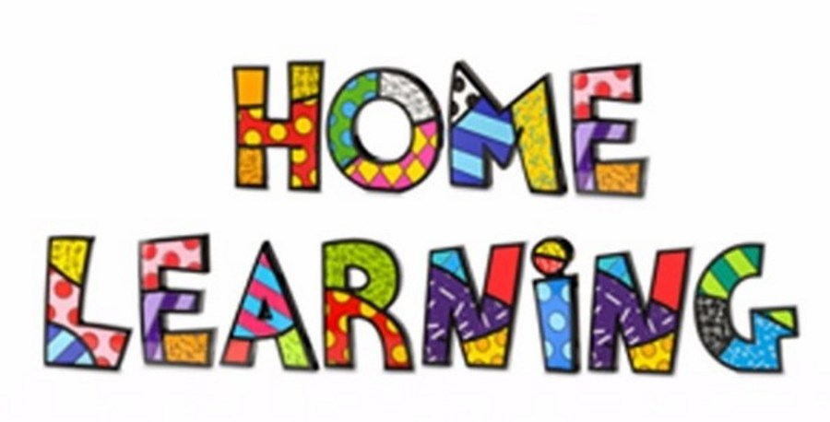
Week 8 – 18.5.2020
Literacy: - Reading
Listen to the story ‘Owl Babies’’. You can find the story on the link below
https://vimeo.com/55971653
https://youtu.be/9U9y35kWBvM
Using the colourful semantic cards, discuss who is in the story. Can the pupils name the characters in the story? Ask the pupils questions about the story? What are the baby owls’ doing? What are the owls’ names? Referring back to the colourful semantic strip. Pupils to answer questions verbally in full sentences.

Task 2
Pupils to write a list of the characters that are in the story. Discuss what they are doing and where they are?

Task 3 – Answer the questions
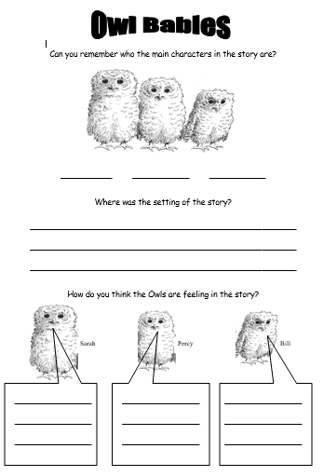

Task 4 (For pupils who go to a RWI group)
RWI
Practice your daily sound book, click on the link below.
https://www.oxfordowl.co.uk/api/interactives/29317.html
Task 4 (Comprehension group)
Read the text and answer the questions. Attached to the webpage.

Parts of an owl
Ask the pupils to label parts of an owl.
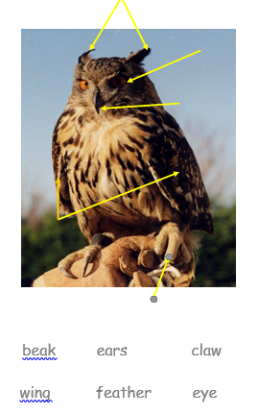

Mathematics
Continue to work on your times tables. You can log into Hwb and practice on J2blast. Log into Hwb with your account details which I sent home in their file. Go to and then click on the J2blast. You can practice your tables and spellings using this program.

Measurement -Capacity
Watch the video on Yutube and answer the questions..
https://www.youtube.com/watch?time_continue=182&v=fXf4KdfNhF0&feature=emb_logo
.
Task 1

Watch the PowerPoint and point to one, which holds more.
Task 2
Watch the PowerPoint and answer the questions. Complete the worksheet attached to the page.
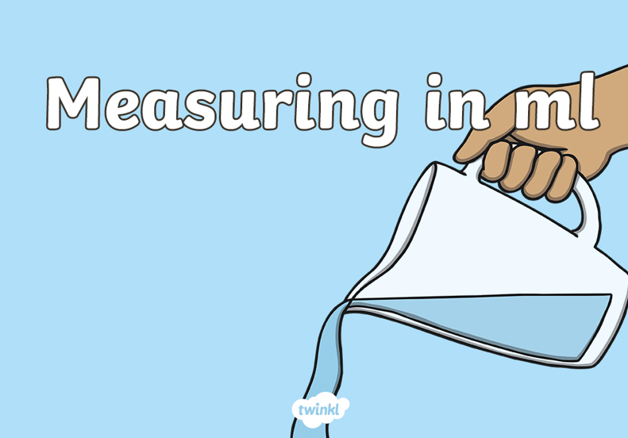
Task 3
Play the capacity interactive game. You can set it at different levels; this will help the children practice their measuring skills.
https://www.topmarks.co.uk/ordering-and-sequencing/coconut-ordering 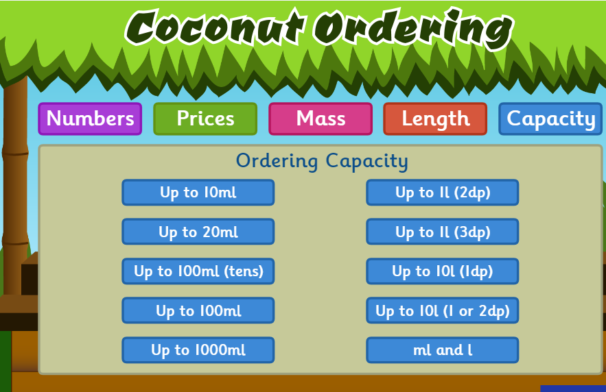

Weekly Maths:- (IEP) Look at missing numbers in a sum ( see below). Please continue to work on this weekly.
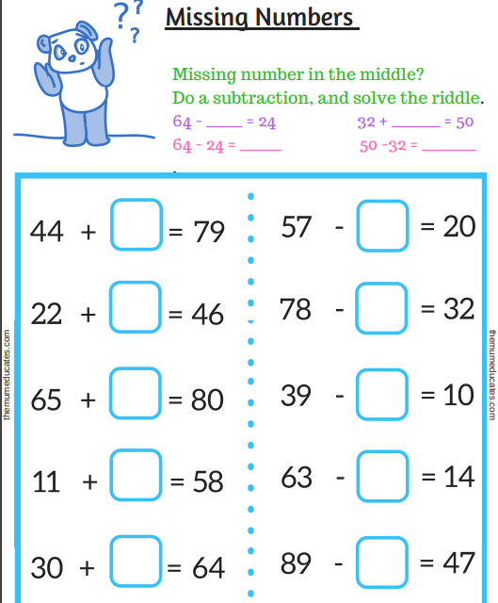

Continue with the addition and subtraction booklets for the pupils on the webpage.

Challenges
Week 7
Challenge 1
Make your own Owl Babies pictures.
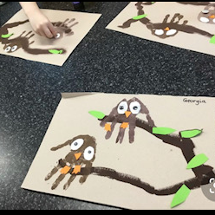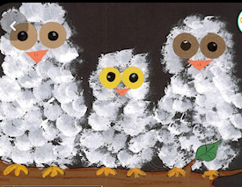
Challenge 2 – Owl biscuits
Have fun cooking with your parents and make some owl biscuits.
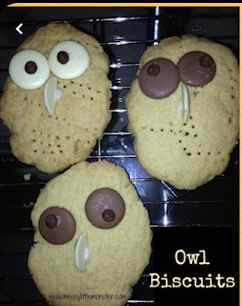

Challenge 3
Go Bird watching! What birds do you find in your garden? Take photographs and post them on Dojo.
Challenge 4
Day and night
Sort the activities that you do into day and night. Worksheet on webpage or draw your own pictures to show what you do in the day and in the night.

Challenge 5
P.E. Challenge:
Join in with Joe Wicks PE 30 min a day via YouTube live every morning at 9am (Mon-Fri). On the other hand, go on a 30 min walk everyday but stay safe.

Challenge 6
Numeracy Challenge
Play games on the following websites, particularly working in number skills such as place value, addition and subtraction
www.topmarks.co.uk ,
www.snappymaths.com
https://www.bbc.co.uk/bitesize/subjects/z826n39

